Whole Data Set
==============

DataSetName: WINDII data files

DataSource: Upper Atmospheric Research Satellite (UARS),
WIND Imaging Interferometer (WINDII)

ScientificContact: Dr. Gordon Shepherd
Department of Earth and Space Science and Engineering
York University
4700 Keele Street
North York, Ontario
Canada M3J 1P3

email: gordon@yorku.ca

Source Characteristics:

These data were derived from the WINDII instrument, which was flown on the UARS spacecraft. The data were processed using the Science Data Production Processing Software (SDPPS), initially run on the Central Data Handling Facility (CDHF) at Goddard Space Flight Center, and then reprocessed at York University. The data contained in this archive are the Level 1 and Level 2 data from the final reprocessing completed at York University in 2013 under a grant from the Canadian Space Agency. Level 1 data are provided at the binning used to acquire the data. Level 2 data combine the measurements from entire images in the determination of single profiles.

The UARS spacecraft had a nearly circular orbit with an average altitude of 585 kilometers and with an inclination of 57 degrees. The orbit precessed about 5 degrees per day relative to the sun, thus over a period of about 72 days the entire diurnal cycle was sampled. For each day of data, the local solar time was nearly constant for a given latitude. Since there are two side to the orbit, ascending and descending, a full range 24 hr range of local time can be viewed every 36 days.

The satellite was rotated in yaw through 180 degrees every 36 days, in order to keep the sun on the same side of the spacecraft and protect the cold side instruments. WINDII was located on the cold side of the spacecraft.

WINDII made its measurements looking at the limb of the atmosphere with two fields of view centred at 45 degrees and 135 degrees from the spacecraft velocity vector. Each field of view (FOV) was 4 degrees (horizontal) by 6 degrees (vertical). The UARS yaw maneuvers dictated the latitudes seen by WINDII. When the spacecraft was flying forward WINDII was looking southward and saw latitudes between 72 degrees south and 42 degrees north. When UARS was flying backwards WINDII was looking northward and saw latitudes between 42 degrees south and 72 degrees north. Thus only the region between 42 degrees south and 42 degrees north was sampled continuously while the high latitudes were sampled on alternating months.

Investigation Objectives:

The WINDII instrument measured winds, temperatures and airglow emission rates in the upper mesosphere and lower thermosphere from observations of the Earth's airglow. Measurements were made both day and night providing global coverage in this region of the atmosphere. These geophysical products may thus be used for further studies of the dynamics of the upper atmosphere and of coupling between the upper and middle atmosphere.

Instrument Attributes:

WINDII was a field widened Michelson interferometer with an eight position filter wheel to select target emissions. It had a large forward baffle which together with limb pointing mirrors and telescopes defined two fixed fields of view. The two FOVs were combined in a field combining prism and were then imaged, side by side, through the Michelson and camera optics onto a charge coupled detector (CCD).

One FOV looked forwards at 45 degrees from the satellite velocity vector and one FOV looked backwards at 135 degrees from the velocity vector. Both FOV boresights were inclined 22.1 degrees below the spacecraft nominal horizontal plane. This gave a maximum altitude coverage of 70 to 300 km for each field of view. The horizontal range was 160 km at the limb in each field of view. Due to the oblateness of the earth the vertical coverage varied by about 20 km over one orbit. The attitude of the UARS satellite was controlled and the final attitude was known so that the look direction was well known. The CCD had 320 pixels in the horizontal, 160 pixels in each FOV, and 256 pixels in the vertical. This gave a maximum altitude resolution of 1 km. In the WINDII data, FD1 refers to the forward looking observations and FD2 to the backward looking.

WINDII was allocated a low bit rate of 2000 bits per second, hence the CCD image area was divided into bins and these bins arranged in windows within each field of view. The airglow emissions measured by WINDII are weak and binning the pixels also improved signal to noise. The binning was done on the CCD and the signal from each bin was converted to a digital value by a 12 bit analog to digital converter. Camera parameters, windowing, exposure time, filter and phase step were transmitted along with the image data for each image. Engineering data were also sent on a separate 1 Kbit/second channel.

Onboard calibration sources were used to monitor the phase of the instrument as part of the normal measurement cycle. These frequent calibrations were taken, along with dark current measurements, every 10 to 15 minutes. A dark current image was taken with the baffle doors closed, all calibration sources turned off and with the same windowing and exposure time as the corresponding atmospheric measurement. The dark current was measured directly in order to track changes in the temperature of the CCD detector. Approximately once a week a full calibration was performed. The data from these infrequent calibrations were analyzed offline in order to look for any changes in the instrument over the course of the UARS mission. When changes were found the Characterization Data Base (CDB) was updated. This CDB was used as input to the SDPPS and was stored as a set of catalogued files. The data files created by the SDPPS contain a reference to the CDB file used. The calibration data are not required to use the level 1 or level 2 data product but are used primarily in the level 0 to level 1 processing.

The normal operating mode of the instrument was to make a measurement of the background followed by an atmospheric emission line measurement. The various measurements were selected by moving a filter wheel which contained 7 interference filters and a blank filter. The sequence of measurements was defined by sequences of filter groups. The filter group was a table stored in memory in the instrument that defined the bin size (number of pixels in the vertical and horizontal), the number of bins in a window (number of rows in the vertical and number of columns in the horizontal). The measurement window could be located anywhere in the field of view. The window location was the same in each of the two fields of view and was defined in the filter group by the number of rows of bins from the bottom of the CCD and the number of pixels in the horizontal from the outer edge of the CCD. The calibration source used for this filter was also defined as was the dark current calibration.

Measured Parameters:

Wind, Temperature and Emission rate with global coverage at 2 to 4 km altitude resolution. Altitude range = 70 to 300 km maximum, the actual range depended on the emission line being observed.

Observed Emission Lines:

The observed emission lines are shown in the following table, along with their wavelengths, the filter number for their observation, the centre wavelength for the filter and its Full Width at Half Maximum.

WINDII observed emissions and the corresponding filter characteristics
Filter No. | Emission | Line wavelength (nm) | Centre wavelength (nm) | FWHM (nm)
1  2  3  4  4  5A  5B  6  7 | Background  O(¹S)  O(¹D)  O⁺(²P)  OH P₁(2)  OH band  OH background  OH P₁(3)  O₂ ^{P}P(7), ^{P}Q(7) | 557.73  630.03  732.0/733.0  731.63  734.09  763.22, 763. | 553.1  558.4  630.7  732.9  728.8  714.8  734.6  763.2 | 1.6  1.6  2.7  1.4  16.3  11.0  1.2  0.09
This table is taken from the paper by Shepherd et al. (1993).

Comments about the measured quantities for each filter are as follows. The text numbers correspond to the filter numbers.
- Background was subtracted from the measurements for Filters 2, 3, 4, 6, and 7. This filter was also used for limited observations of Polar Mesospheric Clouds.
- The O(1S) emission provided high quality wind measurements for the mission, observing both day (85 to 250 km) and night (85 to 115 km). Temperatures were derived from the visibility (modulation depth) of the fringes by assuming a Lorentzian line shape. These temperatures should be valid up to about 130 km owing to thermalization by collision of the excited O(1S) which has a lifetime of about 1 second, but the observations are not consistent with this assumption for reasons unknown.
- The O(1D) emission also provided high quality wind measurements both day and night, from about 150 to 250 km. The long lifetime (110 sec) of the excited species ensures thermalization and so meaningful temperatures are obtained. They may be about 100 K higher than other measurements (Lathuillère, C., W.A. Gault, B. Lamballais, Y.J. Rochon and B.H. Solheim, Ann. Geophysicae, 20, 203-212, 2002).
- This filter observes the O+(2P) thermospheric emission at higher altitudes (upper portion of the field of view) in the daytime only, observing volume emission rates, not winds or temperatures. At lower altitudes (lower part of the field of view), it observes the P1(2) OH line volume emission rate at night.
- This filter observes the whole OH band emission rate and the OH background with a single split filter.
- This filter observes the OH P1(3) line volume emission rate. From this, atomic oxygen concentrations may be obtained. Together with the observations of filters 4 and 5 the goal was to measure rotational temperature from this OH band. However, acceptable results were not obtained, for reasons not known. Winds are possible in principle but have not been validated.
- This filter observes the volume emission rates of the O2 PP(7) and PQ(7) lines. From these the atomic oxygen concentrations may be obtained. Winds are possible in principle, but were not validated.

Data Set Quality:

The data quality is given by the standard deviation of the quantity. Each data element in each file is stored along with a standard deviation which has been calculated by the analysis software. The nominal error is 10 m/s for the wind and 25 K for temperature.

Data Processing Overview:

Raw telemetry for 24 hours was processed from level 0 to 1 using the CDB and georeferencing data provided by UARS. The final data products at level 1 and 2 were created and stored for each 24 hour block of raw telemetry. The data granularity for the WINDII data is one day. All the algorithms used to process the data are defined in detail in various software design documents, however, these are not needed to understand the WINDII data. The algorithms were set up to operate on measurements in sequence. One atmospheric measurement was composed of a background image and 4 (90 degree phase steps), 8 (45 degree phase steps) or 2*4 (90 degree phase steps for each group of 4 images) phase images. A 2*4 phase image measurement is called a "repeated measurement". Frequent calibration measurements were also processed and used with the corresponding atmospheric measurements. A frequent calibration measurement comprised a dark current image and 4 phase images of one of the onboard calibration lamps.

The data processing is divided into three main jobs. The first job reads the raw telemetry files or level 0 data and interprets the data packet headers. The measurements are separated according to the atmospheric line observed and saved in intermediate files. Next the instrument calibration data is used to subtract dark current and to convert the count rate per bin to a line of sight intensity given in Rayleigh. Once the known instrument corrections are made, effects due to the UARS spacecraft are determined. The orbit attitude data are used to compute the location of the tangent point for each line of sight for each measurement bin. The frequent phase measurements are also processed in the first job step. The level 1 data, catalogued at the end of job step 1, contain the calibrated image data and the geo-referencing data. These data are input to job step 2.

WINDII viewed the limb of the airglow and so the intensity measured in each bin was the line of sight integral of the volume emission rate modified by the Michelson interferogram. In the second job step the level 1 bin intensities for each of the 4 or 8 phase steps are used to compute what are termed "apparent quantities". These contain the atmospheric information. The apparent phase is the intensity weighted line integral giving the atmospheric wind. The apparent visibility is the intensity weighted line integral giving the atmospheric temperature. The apparent intensity is the line integral of the volume emission rate. Each measurement is composed of vertical columns of bins. A column gives a vertical scan through the airglow layer. A typical image has 6 columns, each about 25 km wide. In order to reduce the effects of gravity waves on the final wind and temperature values, these 6 columns are averaged together to form a single vertical profile for each field of view. The apparent intensity is inverted using constrained Twomey inversion to give the volume emission rate profile (see "Introduction to the Mathematics of Inversion in Remote Sensing and Indirect Measurements" by S. Twomey, Development in Geomathematics series, Elsevier, New York, 1977). This is then used to deconvolve the apparent phase and visibility. Finally the wind and temperature profiles are computed from the inverted phase and visibility for each field of view. The last step in the level 2 processing is to combine the line of sight winds from each FOV to form the desired vector winds. This is done by selecting data from the forward FOV which overlaps data from the backward FOV. The zonal and meridional components of the wind are computed only if the two FOVs see the same volume and the volume emission rates and temperatures (both scalar quantities) agree within specified limits. The level 2 data are saved for each measurement with no interpolation.

The third job step interpolates the WINDII level 2 data onto a standard grid, level 3 data, defined by the UARS project. These data are not included in the current archive since there is no new information in the level 3 data and interpolation can add errors. It is recommended that the level 2 WINDII data be used with the natural measurement sampling.

Data Usage:

The data may be used to provide global synoptic maps of wind and temperature in the upper mesosphere and lower thermosphere.

Data Organization:

WINDII data are saved in the following directory structure along with detailed file format descriptions.
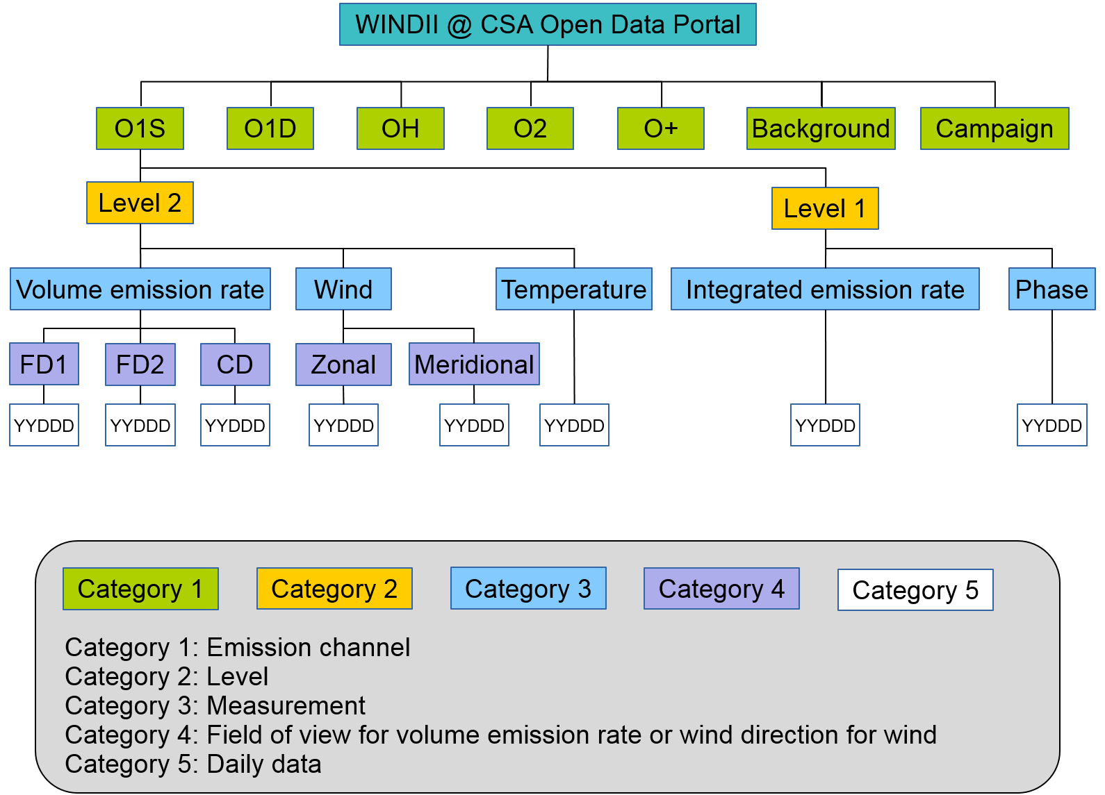

References:

"WINDII, the Wind Imaging Interferometer on the Upper Atmosphere Research Satellite", G.G. Shepherd et al., J. Geophys. Res., 98, 10725, (1993)
"Validation of O(¹S) Wind Measurements by WINDII: the WIND Imaging Interferometer on UARS", W.A. Gault et al., J. Geophys Res., 101, 10,405-10430, (1996)
“The Wind Imaging Interferometer (WINDII) on the Upper Atmosphere Research Satellite: A 20 Year Perspective”, G.G. Shepherd et al., Rev. Geophys., 50, RG2007, doi:10.1029/2012RG000390, (2012).

Credit text:
The archival data were prepared by Young-Min Cho, Brian Solheim and Gordon Shepherd at York University, Toronto, Canada under contract number 45-7014058 from the Canadian Space Agency.

Dataset Citation:
Canadian Space Agency. Wind Imaging Interferometer (WINDII) (2018). Information licensed under the Open Government licence-Canada. [open.canada.ca] | [ https://doi.org/10.xxxx/notfoo.547983. Accessed 1 May 2011]. Credit may be given to the WINDII Team, based at York University, and to the Canadian Space Agency, the Centre national d’études spatiales and the National Aeronautics and Space Administration.

Acknowledgment for use in publications:
Researchers are invited to include the following acknowledgement in any publication for which WINDII data was used: "The authors thank the WINDII Team, supported by the Canadian Space Agency, the Centre national d’etudes spatiales and NASA for providing the WINDII data”.

Registration (Optional):
Users of the WINDII data who wish to receive news or updates can register by sending their names and email to asc.gouvernementouvert-opengovernment.csa@canada.ca. All personal information collected will be governed by the Privacy Act.

