


CANADIAN SPACE AGENCY SPACE EXPLORATION

OPERATIONS AND TRAINING GUIDE
PERFORMANCE READINESS EVALUATION & TRAINING IN A SIMULATED MARS EXPLORATION MISSION (CSA PRET SIMULATOR)

RELEASE 3.0

July 2016

Livelink number: (TBD)



THIS PAGE IS INTENTIONALLY LEFT BLANK

Table of Contents
1. Introduction to CSA PRET MARS Exploration Mission Simulator |  |  | 5
2. Operating the Rover – General Instructions……………………………... |  |  | 6
 | 2.1 CSA PRET Simulator Graphical User Interface (GUI)…………………... |  | 6
 | 2.2 How to Drive the Rover……………………………………………………... |  | 6
 | 2.3 How to Regain Power………………………………………………………... |  | 6
 | 2.4 How to Operate the Sample Arm…………………………………………… |  | 7
 | 2.5 How to Navigate Using the Satellite Map………………………………….. |  | 9
 | 2.6 How to Switch/Change the Main View……………………………………... |  | 10
3. CSA PRET Simulator Messages…………………………………………….. |  |  | 11
 | 3.1 Message Types and their Colour Coding…………………………………... |  | 11
4. CSA PRET Simulator Operations Guide…………………………………. |  |  | 12
 | 4.1 Starting the CSA PRET Simulator………………………………………… |  | 12
 | 4.2 Session Manager Training and Mission Modes……………………………. |  | 12
 | 4.3 PRET Data Files……………………………………………………………... |  | 12
 | 4.4 Login Procedure……………………………………………………………... |  | 13
 | 4.5 Questionnaire……………………………………………………………….. |  | 14
5. CSA PRET Simulator Training Guide……………………………………. |  |  | 16
 | 5.1 Training Session 1…………………………………………………………… |  | 16
 |  | 5.1.1 Session Name………………………………………………………….. | 16
 |  | 5.1.2 Task Description………………………………………………………. | 16
 |  | 5.1.3 Task Instructions……………………………………………………… | 16
 |  | 5.1.4 Task Lessons…………………………………………………………... | 16
 | 5.2 Training Session 2…………………………………………………………… |  | 16
 |  | 5.2.1 Session Name………………………………………………………….. | 16
 |  | 5.2.2 Task Description………………………………………………………. | 17
 |  | 5.2.3 Task Instructions………………………………………………………. | 17
 |  | 5.2.4 Task Lessons…………………………………………………………... | 17
 | 5.3 Training Session 3…………………………………………………………… |  | 17
 |  | 5.3.1 Session Name………………………………………………………….. | 17
 |  | 5.3.2 Task Description………………………………………………………. | 17
 |  | 5.3.3 Task Instructions………………………………………………………. | 17
 |  | 5.3.4 Task Lessons…………………………………………………………... | 18
 | 5.4 Training Session 4…………………………………………………………… |  | 18
 |  | 5.4.1 Session Name………………………………………………………….. | 18
 |  | 5.4.2 Task Description………………………………………………………. | 18
 |  | 5.4.3 Task Instructions………………………………………………………. | 19
 |  | 5.4.4 Task Lessons…………………………………………………………... | 20
 |  | 5.4.5 CIT Validation Results Table…………………………………………. | 21
 |  | 5.4.6 CIT Output File Variable Descriptions……………………………….. | 23
 | 5.5 Training Session 5…………………………………………………………… |  | 24
 |  | 5.5.1 Session Name………………………………………………………….. | 24
 |  | 5.5.2 Task Description………………………………………………………. | 24
 |  | 5.5.3 Task Instructions……………………………………………………… | 24
 |  | 5.5.4 Task Lessons…………………………………………………………... | 25
 |  | 5.5.5 PRMCT Validation Results Table…………………………………….. | 26
 |  | 5.5.6 PMRCT Output File Variable Descriptions…………………………... | 28
 | 5.6 Training Session 6…………………………………………………………… |  | 29
 |  | 5.6.1 Session Name………………………………………………………….. | 29
 |  | 5.6.2 Task Description………………………………………………………. | 29
 |  | 5.6.3 Task Instructions……………………………………………………… | 29
 |  | 5.6.4 Task Lessons…………………………………………………………... | 29
 |  | 5.6.5 RCT Validation Results Table………………………………………… | 30
 |  | 5.6.6 RCT Output File Variable Descriptions………………………………. | 31
 | 5.7 Training Session 7…………………………………………………………… |  | 32
 |  | 5.7.1 Session Name………………………………………………………….. | 32
 |  | 5.7.2 Task Description………………………………………………………. | 32
 |  | 5.7.3 Task Instructions……………………………………………………… | 32
 |  | 5.7.4 Task Lessons…………………………………………………………... | 33
 |  | 5.7.5 GDCCT Validation Results Table…………………………………….. | 34
 |  | 5.7.6 GDCCT Output File Variable Descriptions…………………………... | 36
 | 5.8 Training Session 8…………………………………………………………… |  | 37
 |  | 5.8.1 Session Name………………………………………………………….. | 37
 |  | 5.8.2 Task Description………………………………………………………. | 37
 |  | 5.8.3 Task Instructions……………………………………………………… | 37
 |  | 5.8.4 Task Lessons…………………………………………………………... | 38
 |  | 5.8.5 LNSAT Validation Results Table……………………………………... | 39
 |  | 5.8.6 LNSAT Output File Variable Descriptions…………………………… | 41
 | 5.9 Training Session 9…………………………………………………………… |  | 42
 |  | 5.9.1 Session Name………………………………………………………….. | 42
 |  | 5.9.2 Task Description………………………………………………………. | 42
 |  | 5.9.3 Task Instructions……………………………………………………… | 42
 |  | 5.9.4 Task Lessons…………………………………………………………... | 43
 |  | 5.9.5 SCT Validation Results Table………………………………………… | 44
 |  | 5.9.6 SCT Output File Variable Descriptions………………………………. | 45
6. Installation Instructions……………………………………………………….. |  |  | 46
 | 6.1 Installing CSA PRET Simulator……………………………………………. |  | 46
 | 6.2 Video Settings………………………………………………………………... |  | 46

List of Figures
Figure 1-1: CSA PRET Mars Exploration Mission……………………………………. | 5
Figure 2-1: CSA PRET GUI Panel…………………………………………………….. | 6
Figure 2-2: Power Bonus Icon…………………………………………………………. | 7
Figure 2-3: Switch for Rover Arm Deployment……………………………………….. | 8
Figure 2-4: Manual Positioning of the Rover Arm with Status Window Display……... | 8
Figure 2-5: Correct Alignment of the Rover Arm Indicated in Arm Status Window….. | 9
Figure 2-6: Goal Indication on the Satellite Map………………………………………. | 9
Figure 2-7: View Full Map Window…………………………………………………… | 10
Figure 4-1: PRET GUI Icon……………………………………………………………. | 11
Figure 4-2: Session Manager…………………………………………………………... | 13
Figure 4-3: Main Menu Window………………………………………………………. | 14
Figure 4-4: Login Window……………………………………………………………... | 14
Figure 4-5: Questionnaire Window…………………………………………………….. | 15
Figure 5-1: Rover Alignment at ISRU…………………………………………………. | 17
Figure 5-2: CIT Visual Message Location……………………………………………... | 20
Figure 5-3: PMRCT Mental Computation Task……………………………………….. | 25
Figure 5-4: PMRCT Decision Making Task…………………………………………… | 25
Figure 5-5: RCT Message Displayed in GUI…………………………………………... | 29
Figure 5-6: GDCCT Matching Task…………………………………………………… | 33
Figure 5-7: GDCCT Memory Task…………………………………………………….. | 33
Figure 5-8: LNSAT…………………………………………………………………….. | 38
Figure 5-9: SCT………………………………………………………………………… | 42
Figure 5-10: Response Time Display………………………………………………… | 43
Figure 6-1: Video Setup Window……………………………………………………… | 46

List of Tables
Table 2-1: Satellite Map Icon Descriptions……………………………………………. | 10
Table 5-1: Message Types and Associated Response Keys……………………………. | 19
Table 5-2: CIT Validation Results……………………………………………………... | 21
Table 5-3: CIT Output File Variable Descriptions…………………………………….. | 23
Table 5-4: PMRCT Validation Results………………………………………………… | 26
Table 5-5: PMRCT Output File Variable Descriptions………………………………... | 28
Table 5-6: PMRCT Validation Results………………………………………………… | 30
Table 5-7: RCT Output File Variable Descriptions……………………………………. | 31
Table 5-8: GDCCT Validation Results………………………………………………… | 34
Table 5-9: GDCCT Output File Variable Descriptions………………………………... | 36
Table 5-10: Examples of Coded and Decoded Messages……………………………… | 37
Table 5-11: LNSAT Validation Results……………………………………………….. | 39
Table 5-12: LNSAT Output File Variable Descriptions……………………………….. | 41
Table 5-13: SCT Validation Results…………………………………………………… | 44
Table 5-14: SCT Output File Variable Descriptions…………………………………… | 45

1 Introduction to CSA PRET Mars Exploration Mission Simulator

The CSA Performance Readiness Evaluation Tool (PRET) Mars Exploration Mission Simulator depicts in virtual reality a scenario of a Mars exploration Rover that can be remotely controlled.

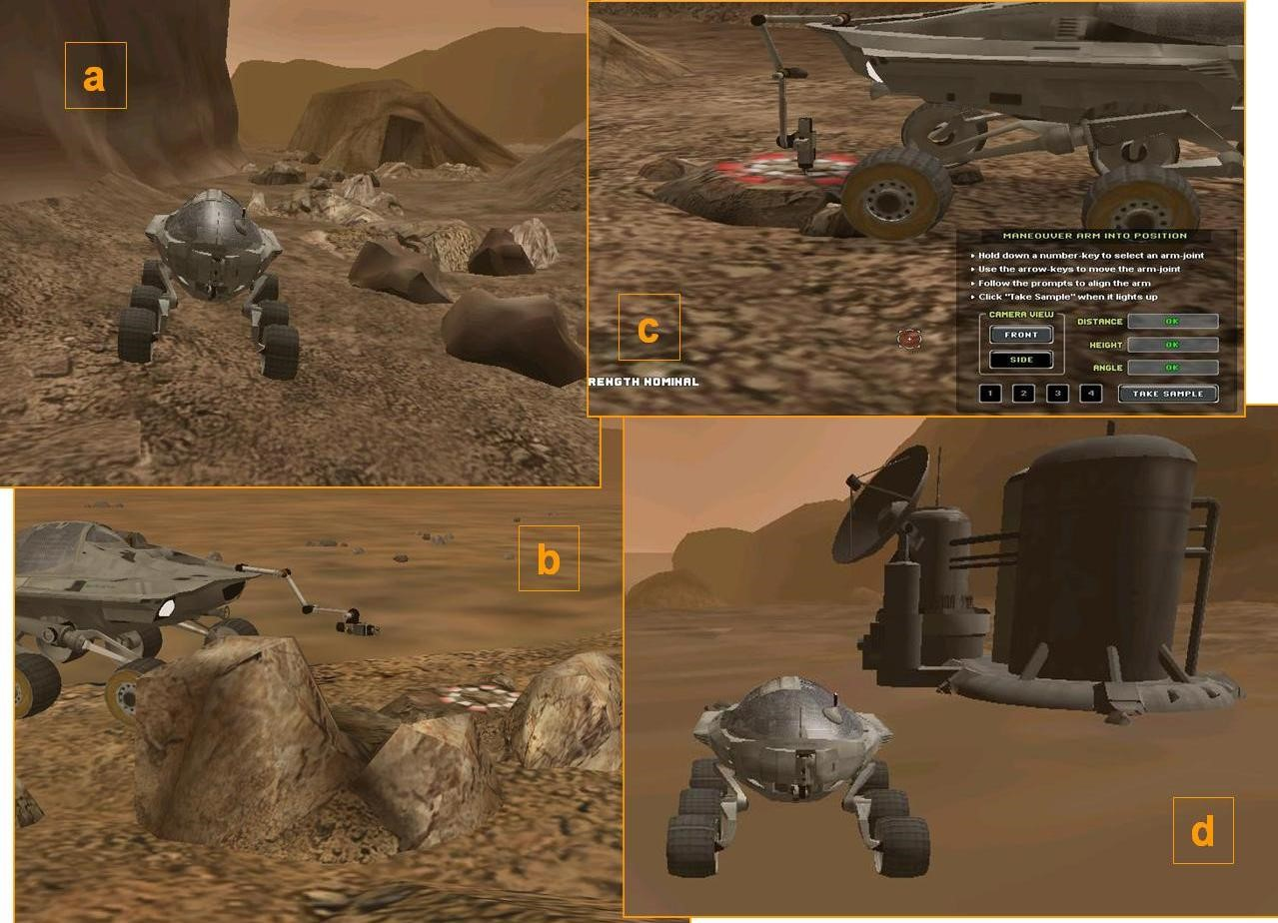
Figure 1-1: CSA PRET Mars Exploration Mission

In the first part of this Mars exploration mission, you are asked to drive the Rover on a rocky surface (Figure 1-1-a) to reach a predetermined target location (Figure 1-1-b). After reaching the target location, the Rover will perform a rock extraction for geological purposes using a tool attached to the end of the Rover’s robotic sample arm (Figure 1-1-c). In the second part of the exploration mission, you are asked to drive the Rover to an In-Situ Resource Utilization (ISRU) site and transfer the core rock sample by properly positioning the Rover at the target location (Figure 1-1-d). During periods of driving, you will be asked to perform several nominal and off-nominal mission tasks that need to be carried out during this exploration mission. In cases where the nominal and off-nominal mission tasks have not been completed by the time the core rock sample has been transferred at the ISRU site, you will be asked to continue the mission by driving to another location.

2 Operating the Rover – General Instructions

2.1 CSA PRET Simulator Graphical User Interface (GUI)
Figure 2-1 shows an image of the CSA PRET GUI panel. It comprises of the following:
- Operator input field or mission control output field (depending on mission task),
- Sample arm deployment/retraction toggle switch,
- Satellite map of surrounding area depicting Rover location and direction to next target location,
- Wheel state indicator,
- Power level indicator,
- Mission clock (elapsed time),
- Main Menu button, and
- Camera view monitors.

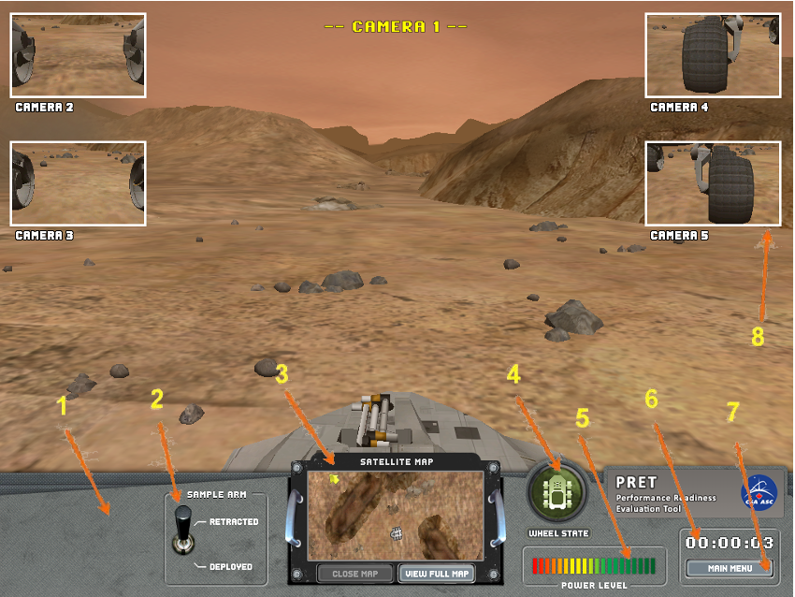
Figure 2-1: CSA PRET GUI Panel

2.2 How to Drive the Rover
Use the arrow keys on your keyboard to drive the Rover. The Up and Down arrow keys move the Rover forwards and backwards, respectively. The Left and Right arrow keys turn the Rover left and right, respectively. The Rover has 4-wheel-steering and can turn 360-degrees in place.

2.3 How to Regain Power
The Rover expends power progressively during the mission. To regain power, you can drive through power bonuses that appear as lightning bolt icons (see Figure 2-2) throughout the mission. These will appear as yellow triangles on the satellite map display.

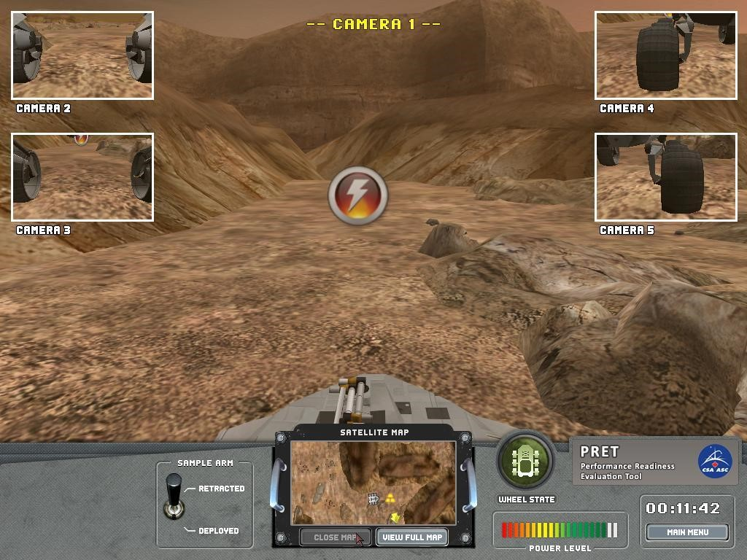
Figure 2-2: Power Bonus Icon

2.4 How to Operate the Sample Arm
At the rock extraction site, a red-and-white target on a nearby rock indicates the location of the to-be-extracted core sample. When you drive close to this location, a side-view of the Rover will be automatically activated. At that point, click on the “Sample Arm” toggle switch to change the switch to the “Deployed” position (Figure 2-3). You can only deploy the arm once the side-view of the Rover is shown. Once the arm is deployed, a Rover arm status window appears (Figure 2-4). The status window shows the selected/active joint, the distance and angle of the core extractor with respect to the target location, and the camera view. The latter can be changed from a side-view to a front view by clicking on the “Camera view” button.

In order to successfully perform a core extraction, you must manually position the sample arm by controlling the arm’s four independent motors. The motors are controlled by pressing numbers 1, 2, 3, or 4 on your keypad to select the base joint (1), middle joints (2 or 3), or the wrist joint (4). The selected/active joint is indicated in the status window (Figure 2-4). Once a joint has been selected, press the arrow keys to move the motors of these joints. All four arrow keys are used to control the base joint (1) whereas only the up/down arrows are used to control joints 2, 3, and 4. When the sample arm is in the correct position for extraction (i.e., distance, height, and angle indicators show “OK”), the red-and white target location will light up and the "Take Sample" button in the Rover arm status window will be enabled (Figure 2-5). Click on the on-screen "Take Sample" button to complete the extraction. It is not necessary for the core extractor (attached to motor 4) to be exactly centred on the red-and-white target to perform the extraction.

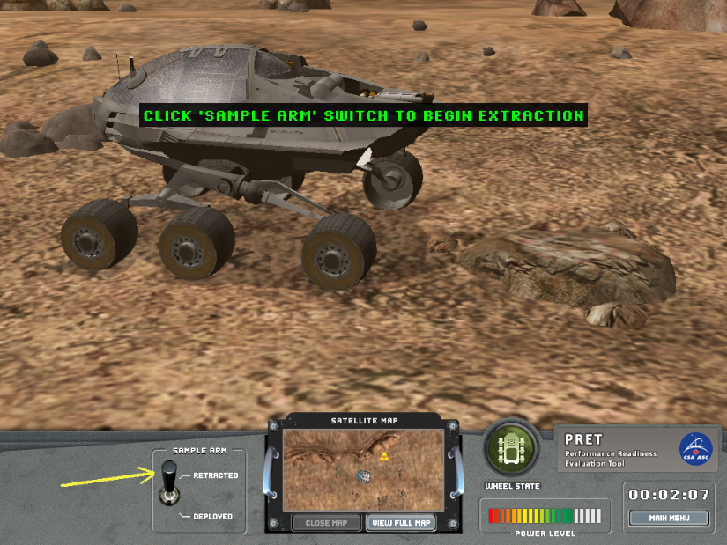
Figure 2-3: Switch for Rover Arm Deployment

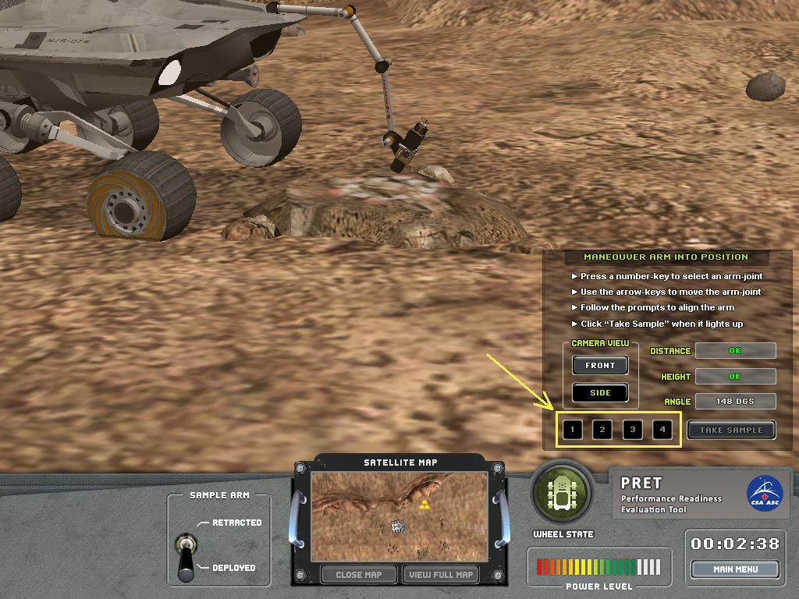
Figure 2-4: Manual Positioning of the Rover Arm with Status Window Displayed

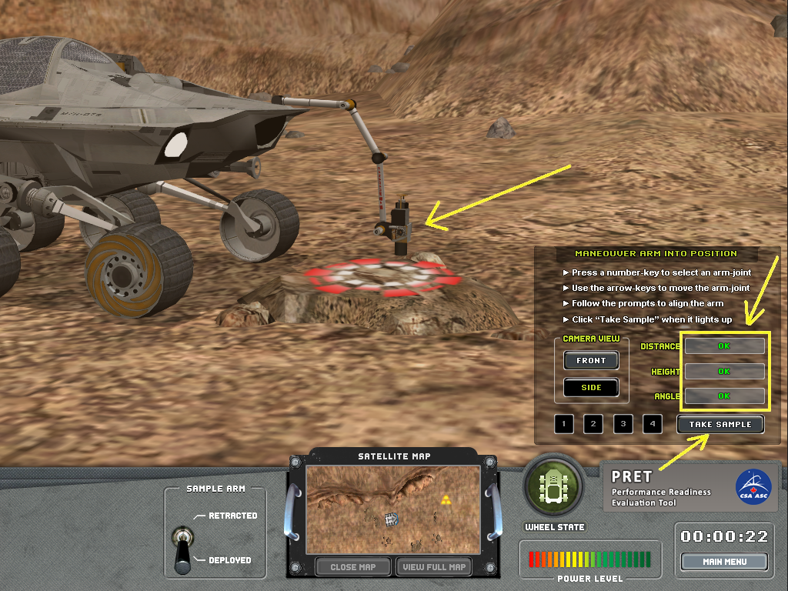
Figure 2-5: Correct Alignment of the Rover Arm Indicated in the Arm Status Window

2.5 How to Navigate Using the Satellite Map
The satellite map on the Rover control panel shows an overview of the Rover’s nearby surroundings with the Rover location indicated by a grey Rover icon, the target (goal) that you are currently pursuing indicated by a blue-and-white icon (see Figure 2-6), the direction to the next target location indicated by a yellow arrow, and the power bonus location(s) indicated by a yellow triangle. These four satellite map icons are shown and described in Table 2-1.

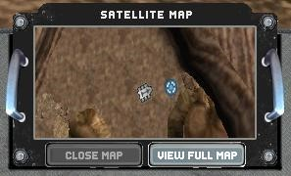
Figure 2-6: Goal Indication on the Satellite Map

Icon | Description
 | Current Location
 | Current Goal
 | Direction to Current Goal (Target)
 | Power Bonus
Table 2-1: Satellite Map Icon Descriptions

In order to see a map of the entire terrain, click on the “View Full Map” button at the bottom right of the Satellite Map window, or press the “M” keyboard key (Figure 2-8). For better visualization, you can zoom in/out by clicking on the buttons at the bottom right of the View Full Map window or move the map by using the Up/Down/Left/Right arrows. The View Full Map window can be closed by clicking on the “Close Map” button or by pressing the “M” key.

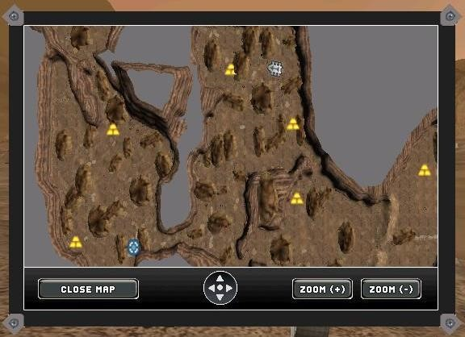
Figure 2-8: View Full Map Window

2.6 How to Switch/Change the Main View
The default main view is Camera 1, which is positioned at the top of the Rover mast. To change the main view, click on a camera monitor to select that camera view, or press CTRL+Number Key to toggle between active camera views (i.e., CTRL+1, CTRL+2, CTRL+3, CTRL+4, CTRL+5) for Cameras 1 through 5, respectively.

3 CSA PRET Simulator Messages

3.1 Message Types and their Colour Coding
Various messages of different types appear in the GUI during the mission. They are color-coded allowing the user to quickly categorize them:

Green | Mission related primary announcements and warnings
Yellow | Mission related secondary announcements and warnings or task specific questions
Red | Task related warnings or mission and GUI critical warnings

4 CSA PRET Simulator Operations Guide

4.1 Starting CSA PRET Simulator
Double-click on the PRET GUI icon on the desktop (Figure 4-1). This will launch Session Manager.

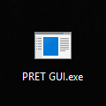
Figure 4-1: PRET GUI Icon

4.2 Session Manager Training and Mission Modes
The Session Manager is the main entry point for running PRET. There are four versions of the software (2.0, 3.0, 4.0, and 5.0) that can be selected using the PRET Session Manager (Figure 4-2). PRET contains a special training mode that allows users to familiarize themselves with the embedded nominal and off-nominal tasks that will occur during the mission.

When in training mode, each task is performed separately. Tasks may be enabled or disabled in the Session Manager using the checkboxes in the “Session Task” panel. Clicking “Begin Next Task” will run the active session task (indicated by the radio button next to the session name) and will return to the Session Manager when the task is complete. The Session Manager will then activate the next enabled task.

When in mission mode, all enabled session tasks are run consecutively without returning to the Session Manager. Specific tasks may be enabled or disabled in the Session Manager via the checkboxes contained in the “Session Task” panel.

4.3 PRET Data Files
When running PRET versions 3.0, 4.0, or 5.0, Comma Separated Values (CSV) log files are created for each completed session task. These files are located in the C:\pretData directory. Each file is named by user/participant number, task, and file creation date. The CSV files contain the user’s/participant’s ID number, date/time, session mode (training or mission) and data specific to each task. The contents of the CSV files are discussed in further detail for each task in Section 5 of this document.

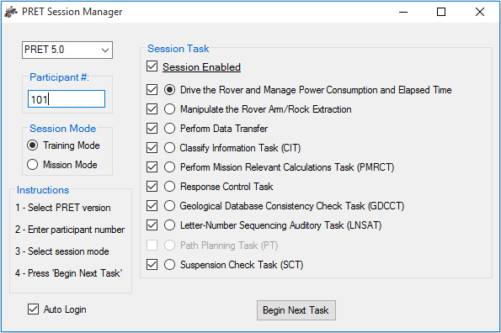
Figure 4-2: Session Manager

4.4 Login Procedure
- Select the version of the PRET software that you want to run via the upper left drop-down box
- Enter a participant number
- Select the session mode (training or mission) via the left hand radio buttons
- If desired, enable the “Auto Login” checkbox in the lower left
- Click the “Begin Next Task” button to launch PRET
- If the “Auto Login” checkbox is checked, PRET automatically begins the session. Otherwise, follow the following login procedure:
  - In the main PRET window, click the “Login/Signup” button (Figure 4-3)
  - In the “Login ID” drop-down box, select the participant name for the current session (Figure 4-4)
  - Click the “Login” button

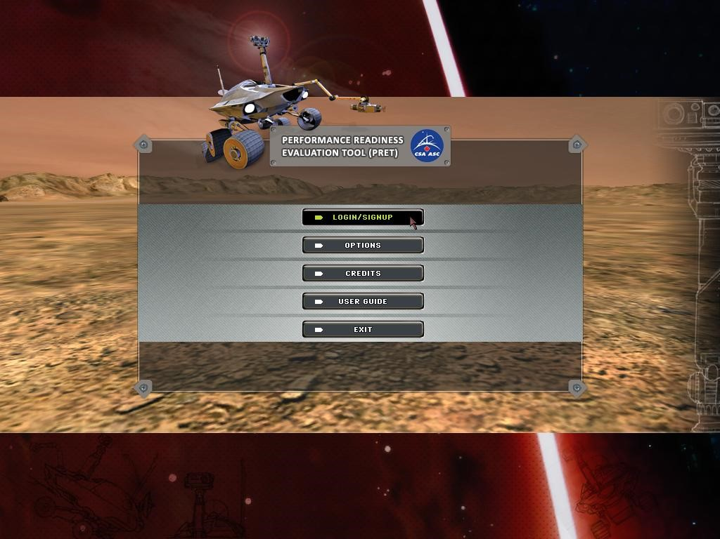
Figure 4-3: Main Menu Window

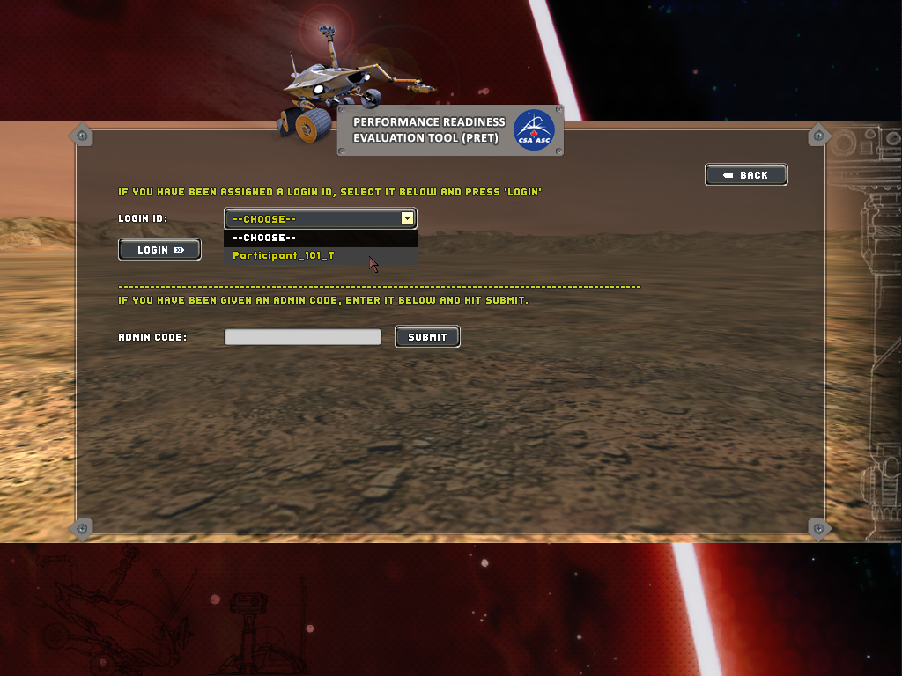
Figure 4-4: Login Window

4.5 Questionnaire
When in Mission Mode you will be asked to complete a brief questionnaire about your mental/physical status prior to each mission (Figure 4-5).

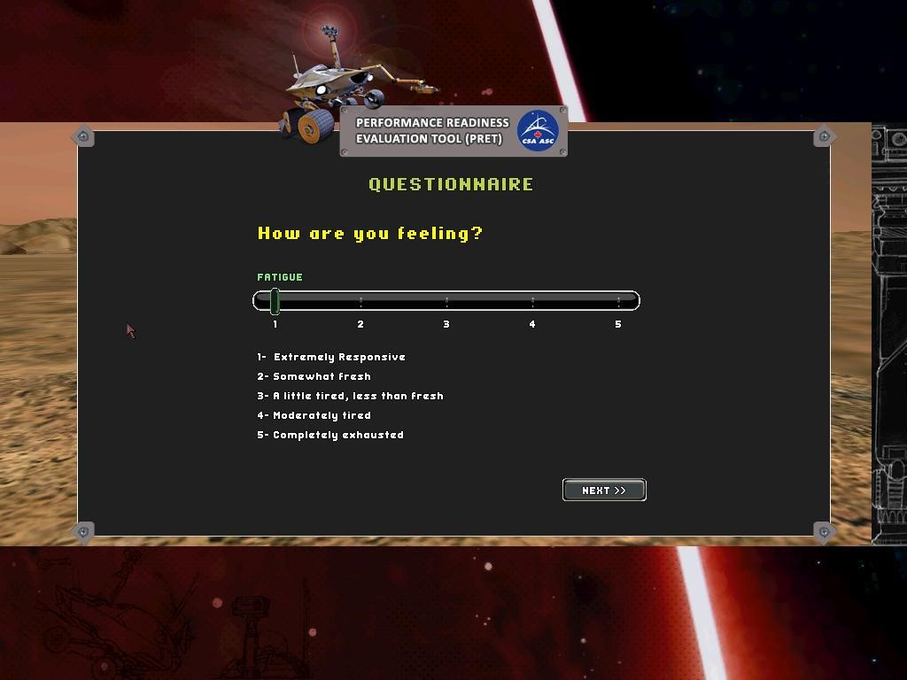
Figure 4-5: Questionnaire Window

5 CSA PRET Simulator Training Guide

This section contains a training guide to accompany the nine sessions you can access by selecting the Training Mode in the Session Mode Manager (Section 4.2). The training mode allows you to practice and become more familiar with the nominal and off-nominal tasks administered in the CSA PRET Simulator. The first three sessions allow you to practice driving the Rover, navigating, using the Rover arm during core extraction, and transferring data at the ISRU site. The next six sessions will introduce you to the tasks that you will need to perform during the mission. Please do NOT take notes during the tasks. The descriptions provided below correspond to the nine training sessions available while in the Training Mode. We recommend you read the corresponding task descriptions outlined in this section prior to practicing the tasks in the Training Mode. It is further recommended that you read the general instructions and background information provided in Sections 1 to 3. For information on how to access the Training Mode and for Login instructions, please see Section 4.
5.1 Training Session 1

5.1.1 Session Name
Drive the Rover and Manage Power Consumption and Elapsed Time
5.1.2 Task Description
The goal of this training session is to learn how to drive the Rover and develop strategies to minimize mission time and optimize the Rover’s power management while driving on the surface of Mars. You will practice driving the Rover on a rocky surface to reach specific target locations. You can control the Rover by using the keyboard arrow keys. In order to reach your target while minimizing time delays, you will learn to navigate and drive the Rover so as to avoid obstacles and stay on course. In order to navigate, you will learn how to use the satellite map. In order to manage Rover power consumption, you will learn how to avoid expending power needlessly and how to gain extra power through power bonuses. Although power is automatically expended during driving, additional power will be needlessly expended due to delays caused by navigation errors or by encountering dust storms. A total loss of power will force the Rover to stop and you will have to wait until the power has been regenerated.
5.1.3 Task Instructions
- For how to drive the Rover, see Section 2.2
- For how to gain power through a power bonus, see Section 2.3
- For how to navigate the Rover using the satellite map, see Section 2.5
5.1.4 Task Lessons
Improve your skills in driving a remotely controlled Rover on the surface of Mars and develop strategies to minimize time and optimize power management of the Rover.

5.2 Training Session 2

5.2.1 Session Name
Manipulate the Rover Arm/Rock Extraction.
5.2.2 Task Description
In this section you will practice how to (1) manually position the Rover’s sample arm in the correct configuration and (2) take a core sample extraction for geological tests.
5.2.3 Task Instructions
For how to manipulate the Rover’s sample arm, see Section 2.4
5.2.4 Task Lessons
Improve your skills in operating the Rover’s sample arm.
5.3 Training Session 3

5.3.1 Session Name
Perform Data Transfer
5.3.2 Task Description
In this section you will practice how to manually align the Rover with the ISRU site to execute a data transfer.
5.3.3 Task Instructions
- For how to drive the Rover, see Section 2.2
- To manually align the Rover, follow the onscreen instructions when at the ISRU site (Figure 5-1)

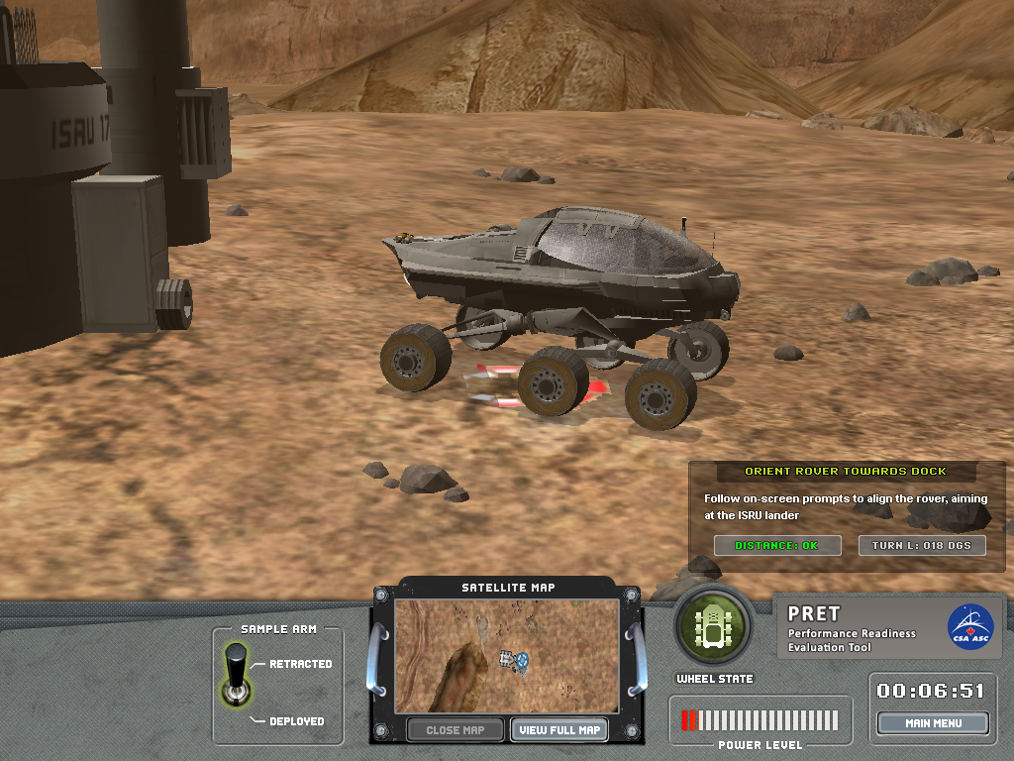

Figure 5-1: Rover Alignment at ISRU
5.3.4 Task Lessons
Improve your skills in accurately positioning the Rover at the ISRU data transfer site.
5.4 Training Session 4

5.4.1 Session Name
Classify Information Task (CIT)
5.4.2 Task Description
This session introduces an additional mission task that you have to perform due to an off-nominal situation: The device that recognizes message types uses an intelligent algorithm that classifies messages received from the mission control center in order to activate related technical verifications. Due to a problem after a computer reboot, the self-learning algorithm needs a training phase to become efficient again in identifying the type of each incoming message. You are asked to perform this training procedure manually by classifying incoming messages. While driving the Rover, visual messages (see Table 5-1) will appear for a few seconds at the bottom-left corner of the screen (see Figure 5-2). To classify the messages, press the appropriate key on the keyboard as quickly as possible. There are two message types (Technical information and Weather information). The message types, their associated response keys, and a complete list of messages that may appear are shown in Table 5-1.

Response  Key | Message Type | Message
<t> | Technical Information | - Communication signal strength nominal  - Software self-check shows systems nominal  - Radiothermal isotope generator nominal  - Satellite signal strength {variable} %  - Network uplink confirmed  - EVTO systems nominal  - Internal heaters running at 74% optimal  - Pancam self-check successful  - Onboard sample analysis {variable} % complete  - Satellite map degraded in cockpit display  - Mobility system check completed  - Power level check underway  - Rover onboard memory levels nominal  - Signal from ISRU at 55% strength  - Internal sensor check successful  - Rover directional control nominal
<w> | Weather Information | - Wind advisory at secondary research unit  - Average wind-speed {variable} m/s (sw | nw)  - Windspeed {variable} m/s (ne | se)  - Air temperature {variable} degrees Celsius  - Dust devils in vicinity  - Temperature decreasing  - External temperature report generating  - External temperature readings normal  - Environmental temperatures normal  - Wind velocity increase predicted  - Weather forecasting system online  - Dust storm activity predicted later today  - Daily weather check delayed  - Surface temperature {variable} degrees Celsius  - Water vapour levels normal  - Upper atmosphere temperature decreasing
Table 5-1: Message Types and Associated Response Keys
5.4.3 Task Instructions
- For how to drive the Rover, see Section 2.2
- For how to gain power through a power bonus, see Section 2.3
- For how to navigate the Rover using the satellite map, see Section 2.5
- To classify a message, read the message that appears on the screen while driving. Decide whether the message conveys Technical or Weather information. If the message is technical, then press the <t> key as quickly as possible. If then message is weather-related, then press the <w> key as quickly as possible.

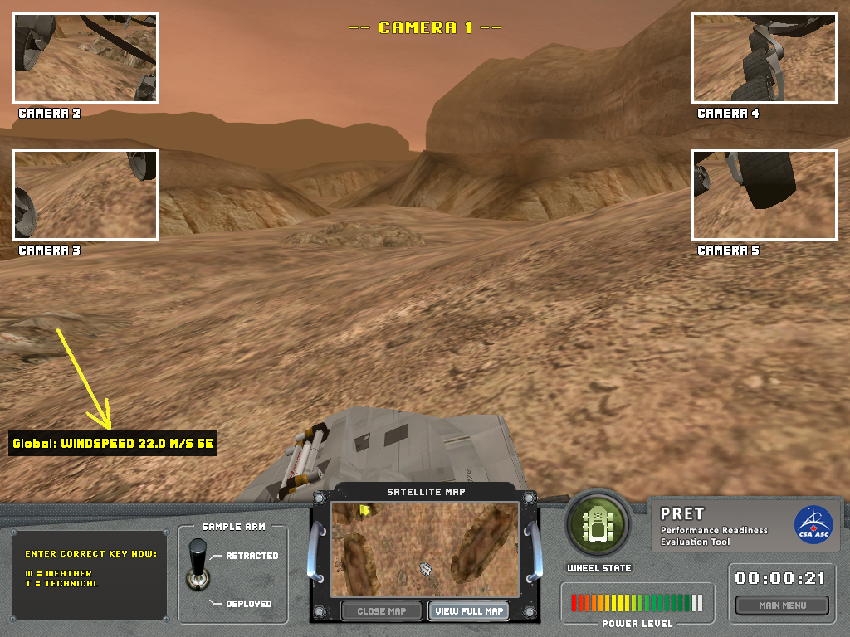
Figure 5-2: CIT Visual Message Location
5.4.4 Task Lessons
Improve your analytical skills in stressful off-nominal situations.

5.4.5 CIT Validation Results Table
Classify Information Task (CIT)
What Does the CIT Measure? The CIT measures the speed and accuracy with which two types of visual messages (technical information and weather information) can be read and categorized.

Test Duration | Mean (s) | Median (s) |  |  | Std. Dev. (s) |  |  |  | Minimum (s) |  |  |  |  | Maximum (s)
 | 160 | 157 |  |  | 26 |  |  |  | 91 |  |  |  |  | 217
Distributional Characteristics |  |  |  | Response Time |  | Throughput |  |  |  | Accuracy |  |  |  |  | Miss Rate
Mean |  |  |  | 2137 ms |  | 22.2 |  |  |  | 90.0% |  |  |  |  | 22.9%
Median |  |  |  | 2140 ms |  | 21.5 |  |  |  | 91.7% |  |  |  |  | 18.8%
Std. Dev. |  |  |  | 366 ms |  | 9.2 |  |  |  | 9.0% |  |  |  |  | 19.2%
Inter-Quartile Range |  |  |  | 568 ms |  | 13.3 |  |  |  | 10.0% |  |  |  |  | 24.9%
Minimum |  |  |  | 1361 ms |  | 1.7 |  |  |  | 52.4% |  |  |  |  | 0.0%
Maximum |  |  |  | 3432 ms |  | 43.6 |  |  |  | 100.0% |  |  |  |  | 90.6%
Skewness |  |  |  | .250 |  | .197 |  |  |  | -1.58 |  |  |  |  | 1.06%
Kurtosis |  |  |  | -.083 |  | -.539 |  |  |  | 3.14 |  |  |  |  | .564
Normally Distributed? |  |  |  | Yes |  | Yes |  |  |  | No |  |  |  |  | No
Spearman Test-Retest Reliability |  |  |  | 1-Week |  |  | 4-Week |  |  |  |  | Medical Scenario
 |  |  |  | .773 |  |  | .790 |  |  |  |  | .905
Learning Curve |  |  |  |  |  |  |  |  |  |  | Stabilization
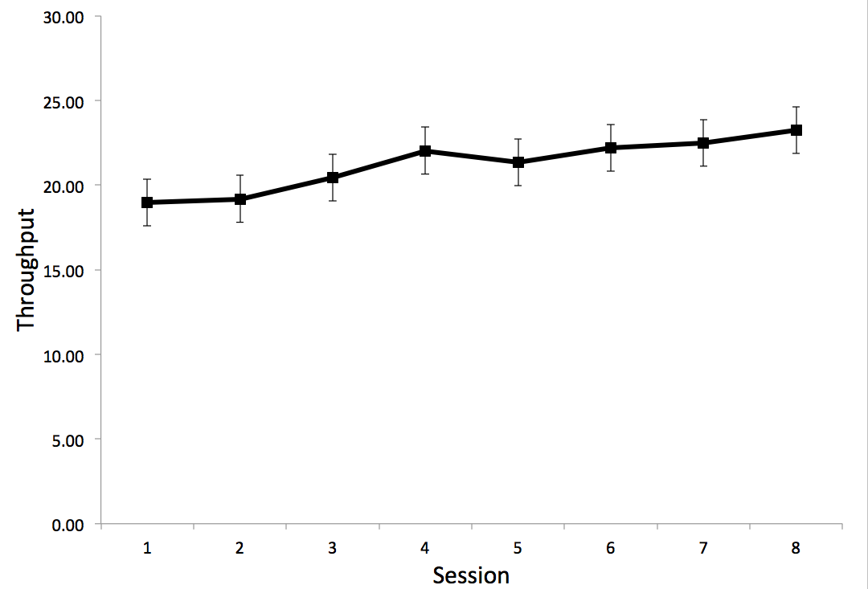 |  |  |  |  |  |  |  |  |  |  | Throughput performance on the CIT plateaus at Session 6
Correlations with Similar Neurocognitive Tests
DANA Procedural RT Test
- Weakly correlated for response time (r_{p} = .24) and throughput (r_{p} = .26)

WinSCAT Continuous Processing Test
- Weakly correlated for response time (r_{p} = .39) and throughput (r_{p} = .26)

TOVA
- Weakly correlated for response time (r_{p} = .25)
- Weak correlation between CIT miss rate and TOVA response time (r_{p} = .34)

PASAT
- Weak correlation between CIT response time and PASAT errors (r_{p} = .27)
- Weak correlation between CIT miss rate and PASAT errors (r_{p} = .28)

WAIS-IV Symbol Search
- Weak correlation between CIT response time and Symbol Search score
- Weak correlation between CIT miss rate and Symbol Search score (r_{p} = -.21)
Test-Retest Reliability Comparisons with Similar Neurocognitive Tests
 |  |  | 1-Week  Test-Retest  Reliability |  |  |  |  | 4-Week  Test-Retest  Reliability |  |  |  |  | Medical Scenario  Test-Retest Reliability
CIT |  |  | .773 |  |  |  |  | .790 |  |  |  |  | .905
DANA Procedural RT |  |  | .610 |  |  |  |  | .729 |  |  |  |  | .720
WinSCAT Continuous Processing Test |  |  | .784 |  |  |  |  | .881 |  |  |  |  | .896
Table 5-2: CIT Validation Results

5.4.6 CIT Output File Variable Descriptions
Variable Name | Description
ID | Participant ID
Date_Time | Date/Time stamp: YYYY_MM_DD_HH:MM:SS
SessionMode | Session mode (0=Training, 1=Mission)
SessionID | Participant session number
Phase | Driving phase (1=before extraction, 2=between extraction and ISRU site, 3=after ISRU site)
Trial | Trial number (two blocks of 15 trials each; 30 trials total)
Message_Type | 1=Technical message; 2=Weather message
Message_Code | Unique ID for each message
Response | Participant’s response (T=Technical, W=Weather, NO_KEY=No response)
RT | Response time in seconds
ACC | Response accuracy (-1=No response, 0=Incorrect, 1=Correct)
Table 5-3: CIT Output File Variable Descriptions

5.5 Training Session 5

5.5.1 Session Name
Perform Mission Relevant Calculations Task (PMRCT)
5.5.2 Task Description
In this session you have to make a decision based on repeated calculations of the speed and distance of a nearby dust storm. You will be presented with two audio/visual sources of information: (1) the storm speed (audio) and (2) the time until the storm time reaches the Rover (visual). You will be required to calculate the distance of the storm from the Rover by multiplying these two values. There will be five consecutive presentations of storm speed/time values, with the values changing for each presentation. The storm distance will either decrease or increase over these five presentations. If the storm is approaching, then you should decide to stop the Rover and wait for the storm to pass while the Rover automatically activates the Power Enhancement Mechanism (PEM). If the storm is receding, then you should decide to continue with your mission. A dust storm affects the electronic mechanism of the Rover and depletes its power reserves. The PEM activates a spare battery that boosts the Rover's primary battery and prevents loss of energy.
5.5.3 Task Instructions
- For how to drive the Rover, see Section 2.2
- For how to navigate the Rover using the satellite map, see Section 2.5
- To perform the required mission relevant calculations and make decisions (regarding whether to stop the Rover or continue with the mission), you have to attend, analyze, and respond to the information presented:
- After hearing the storm speed and seeing the time until the storm reaches the Rover, mentally calculate the distance of the storm from the Rover and respond by entering the storm distance value in the input field in the bottom-left corner of the screen (Figure 5-3).
- Perform five consecutive mental calculations of the storm distance remember whether these distances are increasing (storm approaching) or decreasing (storm receding).
- Decide to either (a) stop the Rover by pressing the “Y” key and wait for the storm to pass or (b) continue with the mission by pressing the “N” key (Figure 5-4).

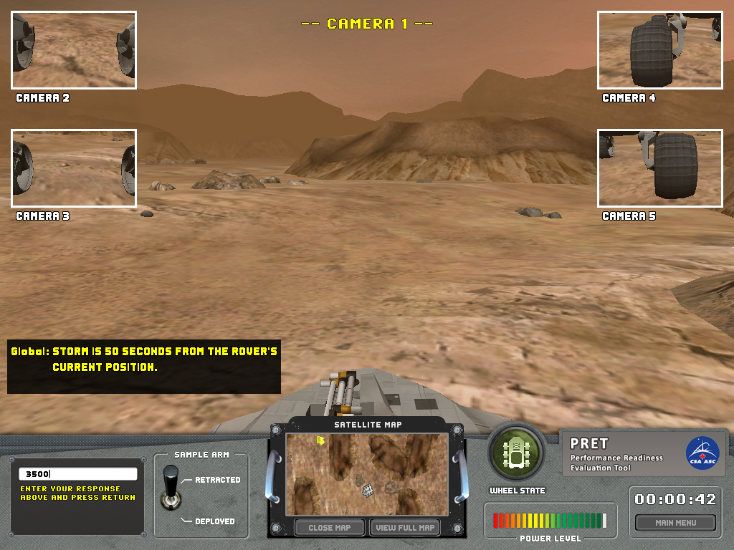
Figure 5-3: PMRCT Mental Computation Task

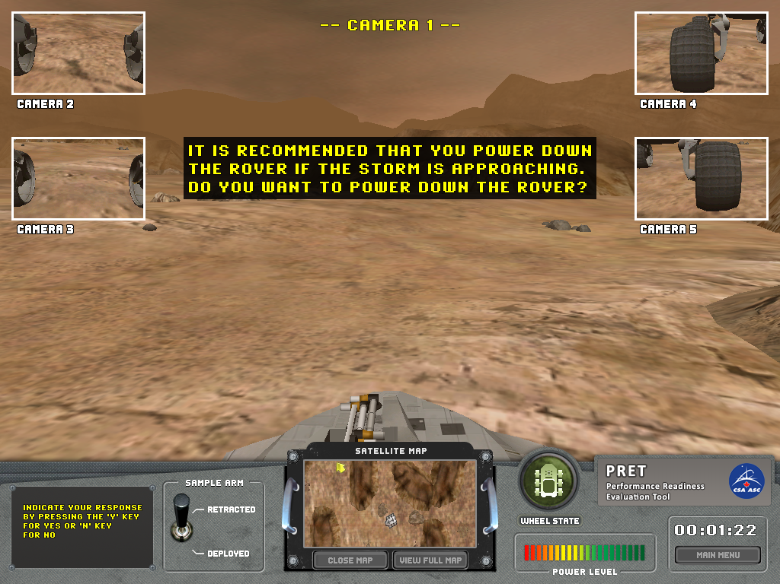
Figure 5-4: PMRCT Decision Making Task
5.5.4 Task Lessons
Improve your ability to identify and analyze mission relevant information and perform mental calculations.

5.5.5 PMRCT Validation Results Table
Perform Mission Relevant Calculations Task (PMRCT)
What Does the PMRCT Measure? The PMRCT measures the speed and accuracy with which two values presented in different modalities (auditory and visual) can be mentally multiplied. The PMRCT also measures the speed and accuracy with which a decision can be made based on the user’s ability to remember the results of five separate mental computations.
Test Duration | Mean (s) |  |  | Median (s) |  |  |  |  | Std. Dev. (s) |  |  | Minimum (s) |  |  | Maximum (s)
 | 43 |  |  | 39 |  |  |  |  | 14 |  |  | 22 |  |  | 121
Distributional Characteristics |  | Response Time |  |  |  |  |  | Throughput |  |  |  |  |  | Accuracy
 |  | Calc. |  |  | Decision |  |  | Calc. |  |  | Decision |  |  | Calc. |  |  | Decision
Mean |  | 6277 ms |  |  | 7418 ms |  |  | 10.3 |  |  | 13.6 |  |  | 76.7 % |  |  | 93.2 %
Median |  | 5400 ms |  |  | 5155 ms |  |  | 9.6 |  |  | 11.6 |  |  | 80.0 % |  |  | 100.0 %
Std. Dev. |  | 3075 ms |  |  | 7575 ms |  |  | 6.1 |  |  | 9.2 |  |  | 24.3 % |  |  | 16.9 %
Inter-Quartile Range |  | 3598 ms |  |  | 4590 ms |  |  | 9.5 |  |  | 11.2 |  |  | 40.0 % |  |  | 0.0 %
Minimum |  | 2626 ms |  |  | 1118 ms |  |  | 1.2 |  |  | 1.2 |  |  | 18.0 % |  |  | 10.0 %
Maximum |  | 19634 ms |  |  | 42984 ms |  |  | 25.2 |  |  | 53.7 |  |  | 100.0 % |  |  | 100.0 %
Skewness |  | 1.57 |  |  | 2.82 |  |  | .336 |  |  | 1.38 |  |  | -.997 |  |  | -2.76
Kurtosis |  | 2.95 |  |  | 8.35 |  |  | -.898 |  |  | 2.90 |  |  | .050 |  |  | 7.38
Normally Distributed? |  | No |  |  | No |  |  | No |  |  | No |  |  | No |  |  | No
Spearman Test-Retest Reliability |  | 1-Week |  |  |  |  |  | 4-Week |  |  |  |  |  | Medical Scenario
 |  | Calc. |  |  | Decision |  |  | Calc. |  |  | Decision |  |  | Calc. |  |  | Decision
 |  | .444 |  |  | .361 |  |  | .475 |  |  | .492 |  |  | .407 |  |  | .455
Calculation  Learning Curve |  |  |  |  |  |  | Decision  Learning Curve
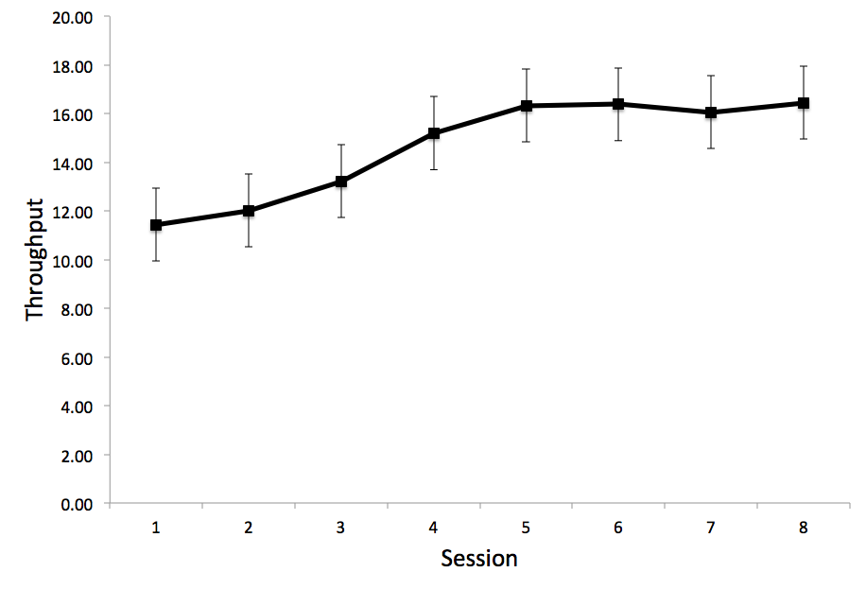 |  |  |  |  |  |  | 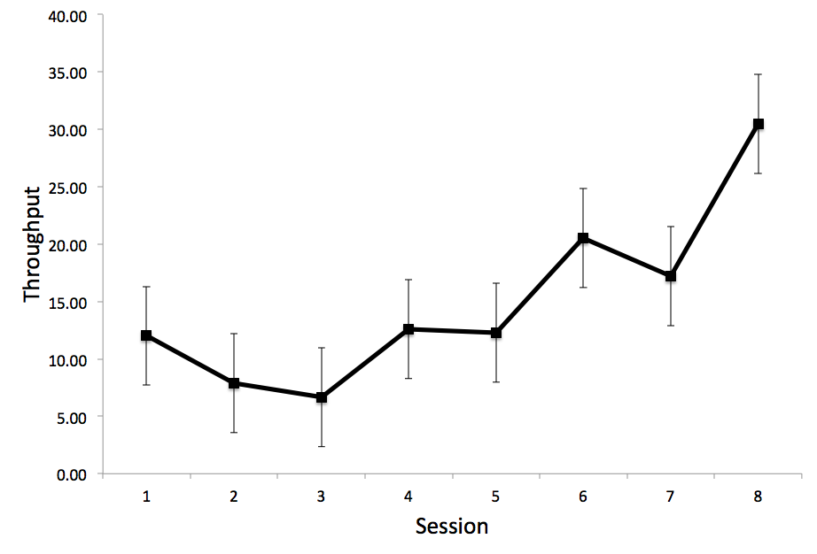
Stabilization
Throughput performance on PMRCT Calculation plateaus at Session 4 |  |  |  |  |  |  | Throughput performance on PMRCT Decision did not plateau after 8 sessions
Correlations with Similar Neurocognitive Tests
Calculation |  |  |  |  |  |  | Decision
WinSCAT Math  - Weakly correlated for response time (r_{p} = .23) and accuracy (r_{p} = .28)  WAIS-IV Arithmetic  - Weak correlation between PMRCT response time and Arithmetic score  - Weak correlation between PMRCT accuracy and Arithmetic score  DKEFS Switch Test  - Weak correlation between PMRCT accuracy and Switch test errors (r_{p} = -.24)  PASAT  - Weak correlation between PMRCT response time and PASAT errors (r_{p} = .34)  WMS-IV Spatial Addition  - Weak correlation between PMRCT response time and Spatial Addition score (r_{p} = -.25)  WMS-IV Spatial Span  - Weak correlation between PMRCT response time and Spatial Span score (r_{p} = -.31) |  |  |  |  |  |  | WAIS-IV Arithmetic  - Weak correlation between PMRCT response time and Arithmetic score (r_{p} =  -.24)  PASAT  - Weak correlation between PMRCT response time and PASAT errors (r_{p} = .25)  WMS-IV Spatial Span  - Weak correlation between PMRCT response time and Spatial Span score  - Weak correlation between PMRCT accuracy and Spatial Span score (r_{p} = .24)
Test-Retest Reliability Comparisons with Similar Neurocognitive Tests
 | 1-Week  Test-Retest  Reliability |  |  |  |  | 4-Week  Test-Retest  Reliability |  |  |  |  |  |  | Medical Scenario  Test-Retest Reliability
 | Calc. |  | Decision |  |  | Calc. |  |  |  | Decision |  |  | Calc. |  |  | Decision
PMRCT | .444 |  | .361 |  |  | .475 |  |  |  | .492 |  |  | .407 |  |  | .455
DANA  Memory Search |  |  | .411 |  |  |  |  |  |  | .511 |  |  |  |  |  | .598
WinSCAT  Math | .570 |  |  |  |  | .637 |  |  |  |  |  |  | .624
Table 5-4: PMRCT Validation Results
5.5.6 PMRCT Output File Variable Descriptions
Variable Name | Description
ID | Participant ID
Date_Time | Date/Time stamp: YYYY_MM_DD_HH:MM:SS
SessionMode | Session mode (0=Training, 1=Mission)
SessionID | Participant session number
StormSpeed | Displayed storm speed in m/s
StormETA | Displayed estimated time of storm arrival in seconds
StormDistance | Storm distance (Stormspeed x StormETA)
UserDistance | Participant’s calculated storm distance
StormType | Storm type (1=Receding, 2=Approaching)
CalculationACC | Calculation accuracy (0=Incorrect, 1=Correct)
CalculationRT | Calculation response time in seconds
DecisionACC | Decision accuracy (-1=No decision required, 0=Incorrect, 1=Correct)
DecisionRT | Decision response time in seconds
TrialID | Trial number (1-5)
Table 5-5: PMRCT Output File Variable Descriptions

5.6 Training Session 6

5.6.1 Session Name
Response Control Task (RCT)
5.6.2 Task Description
The RCT is a task that you have to perform while driving the Rover in order to let Mission Control know that you are receiving the messages that they are sending. This is important since, in addition to the relevant messages being sent to you (the Rover operator), you will also receive irrelevant messages being exchanged between the ISRU site transmitter and the Mission Control Centre. Your task is to ignore the irrelevant messages while acknowledging the relevant messages.
5.6.3 Task Instructions
- To inform the Mission Control Centre that you have received mission relevant information, you need to attend to the relevance of the visual messages displayed while driving the Rover. You are to ignore the irrelevant messages (make no response) and confirm the receipt of relevant messages by pressing the space bar. The relevant message that you are to acknowledge by pressing the space bar is: “Global: Your manoeuvres are followed by mission control. Acknowledge by pressing the space bar” (Figure 5-5).

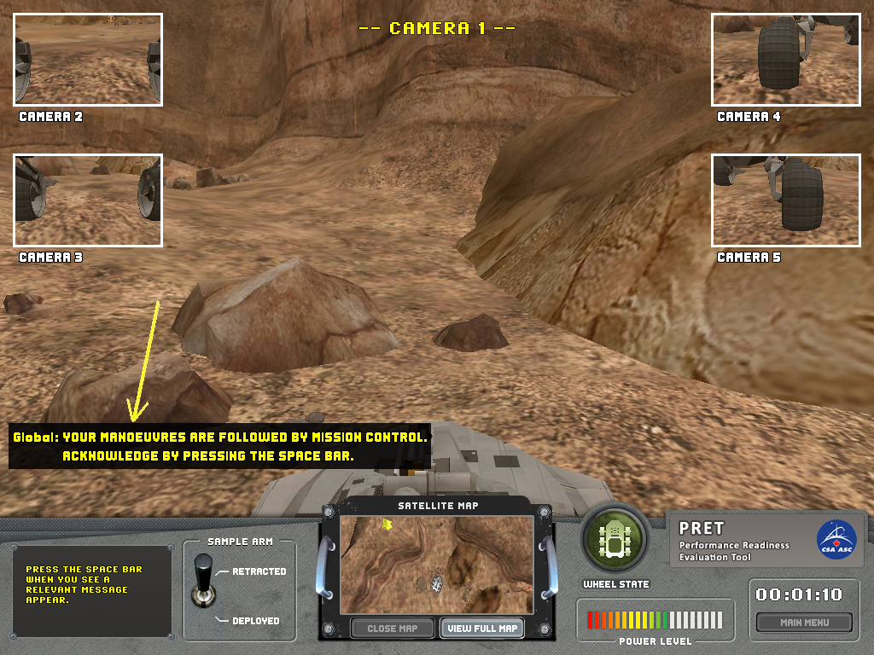
Figure 5-5: RCT Message Displayed in GUI
5.6.4 Task Lessons
Improve your ability to analyze situations and recognize relevant information in a multi-tasking context.

5.6.5 RCT Validation Results Table
Response Control Test (RCT)
What Does the RCT Measure? The RCT measures the ability to ignore (withhold a response) irrelevant visual information and the speed with which relevant information can be responded to.
Test Duration | Mean (s) |  | Median (s) |  |  | Std. Dev. (s) |  |  |  | Minimum (s) |  |  |  |  | Maximum (s)
 | 917 |  | 921 |  |  | 203 |  |  |  | 266 |  |  |  |  | 1359
Distributional Characteristics |  |  |  | Response Time |  |  |  | Throughput |  |  | Hit Rate |  |  |  |  | Rejection Rate
Mean |  |  |  | 1776 ms |  |  |  | 23.7 |  |  | 62.3 % |  |  |  |  | 90.0 %
Median |  |  |  | 1749 ms |  |  |  | 22.5 |  |  | 60.0 % |  |  |  |  | 100.0 %
Std. Dev. |  |  |  | 464 ms |  |  |  | 12.6 |  |  | 25.4 % |  |  |  |  | 17.5 %
Inter-Quartile Range |  |  |  | 635 ms |  |  |  | 18.9 |  |  | 40.0 % |  |  |  |  | 10.7 %
Minimum |  |  |  | 559 ms |  |  |  | 0.6 |  |  | 2.9 % |  |  |  |  | 15.0 %
Maximum |  |  |  | 2971 ms |  |  |  | 65.8 |  |  | 100.0 % |  |  |  |  | 100.0 %
Skewness |  |  |  | .411 |  |  |  | .491 |  |  | -.242 |  |  |  |  | -1.99
Kurtosis |  |  |  | -.038 |  |  |  | -.145 |  |  | -.800 |  |  |  |  | 3.62
Normally Distributed? |  |  |  | No |  |  |  | No |  |  | No |  |  |  |  | No
Spearman Test-Retest Reliability |  |  |  |  | 1-Week |  |  |  | 4-Week |  |  |  |  | Medical Scenario
 |  |  |  |  | .472 |  |  |  | .622 |  |  |  |  | .647
Learning Curve |  |  |  |  |  |  |  |  |  |  |  | Stabilization
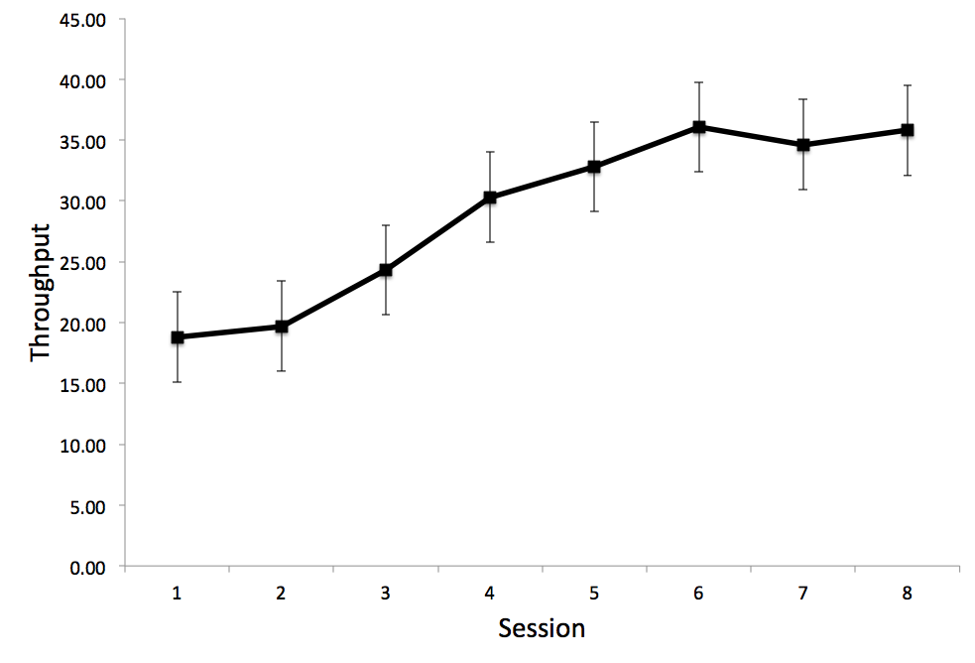 |  |  |  |  |  |  |  |  |  |  |  | Throughput performance on the RCT plateaus at Session 6
Correlations with Similar Neurocognitive Tasks
DANA Go/No-Go Test
- Moderately correlated for response time (r_{p} = .40) and throughput (r_{p} = .55)
- Weakly correlated for hit rate (r_{p} = .28)
Test-Retest Reliability Comparisons with Similar Neurocognitive Tests
 |  | 1-Week  Test-Retest  Reliability |  |  |  |  | 4-Week  Test-Retest  Reliability |  |  |  |  |  | Medical Scenario  Test-Retest Reliability
RCT |  | .472 |  |  |  |  | .622 |  |  |  |  |  | .647
DANA  Go/No-Go |  | .666 |  |  |  |  | .728 |  |  |  |  |  | .678
Table 5-6: RCT Validation Results

5.6.6 RCT Output File Variable Descriptions
Variable Name | Description
ID | Participant ID
Date_Time | Date/Time stamp: YYYY_MM_DD_HH:MM:SS
SessionMode | Session mode (0=Training, 1=Mission)
SessionID | Participant session number
Phase | Driving phase (1=before extraction, 2=between extraction and ISRU site, 3=after ISRU site)
Trial | Trial number
Message_Type | Message type (0=Irrelevant, 1=Relevant)
Response | Participant response (0=Did not respond, 1=Responded)
RT | Response time in seconds (2000 for misses)
ACC | Response accuracy (0=Miss/False Alarm, 1=Hit/Correct Rejection)
Table 5-7: RCT Output File Variable Descriptions

5.7 Training Session 7

5.7.1 Session Name
Geological Database Consistency Check Task (GDCCT)
5.7.2 Task Description
The GDCCT is a mission task that is to be performed in an off-nominal situation to verify that the core samples that you have collected are the correct ones. The automated sample classification system is malfunctioning and manual verification is required. Analyzed core rock samples are classified according to the geological site where they were collected. For identification purposes, a unique symbol is associated with each rock sample. This symbol is then associated with the extraction site ID number. The central mission planning database (physically located on Earth) contains all the planned sample identification markers (consisting of symbol/number pairs). To verify that the correct samples were collected, you are required to compare the identification codes of the newly collected samples with those stored in the database on Earth.
5.7.3 Task Instructions
To manually verify that you have collected the correct core samples, you have to conduct the following two-part procedure:
- In Part 1, you are shown a panel with a set of ten (10) symbol-number pairs and one single symbol-number pair underneath (Figure 5-6). Your task is to indicate whether the single symbol-number pair is a match or a non-match in the set of 10 pairs shown above. Press the “Y” key if the pair matches. Press the “N” key if the pair does not match. A total of 80 symbol-number pairs will be consecutively shown.
- In Part 2, you are shown only individual symbol-number pairs (Figure 5-7). You have to recall whether the given single symbol-number pair was also displayed in the set of 10 symbol-number pairs that was shown in Part 1. A total of 20 symbol-number pairs will be consecutively shown.

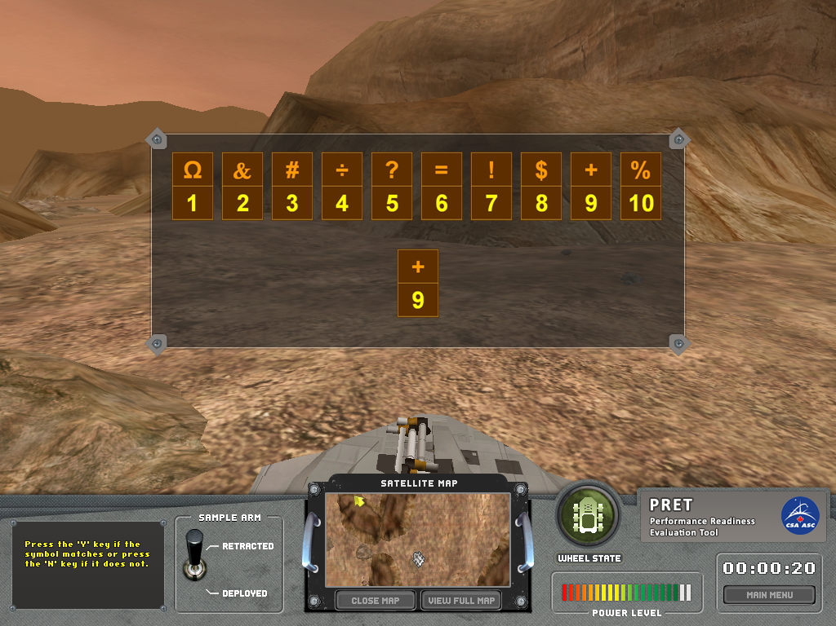
Figure 5-6: GDCCT Matching Task

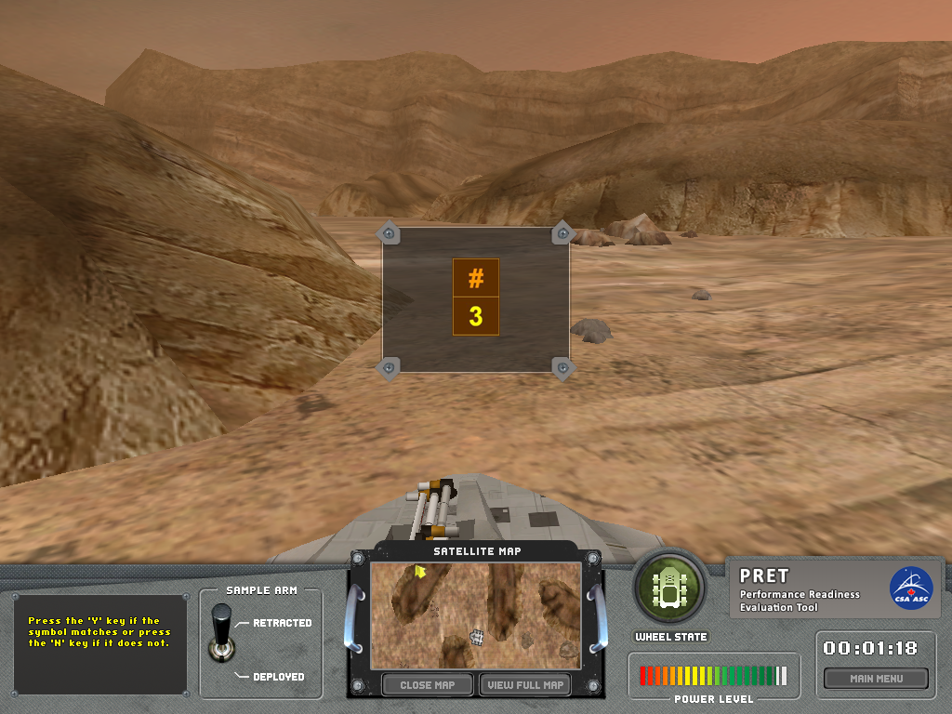
Figure 5-7: GDCCT Memory Task

5.7.4 Task Lessons
Improve your ability to memorize and relay mission specific information in an off-nominal situation.

5.7.5 GDCCT Validation Results Table
Geological Database Consistency Check Task (GDCCT)
What Does the GDCCT Measure? The GDCCT measures the speed and accuracy with which visual information can be matched and later recalled.
Test Duration | Mean (s) |  | Median (s) |  |  |  |  | Std. Dev. (s) |  |  |  |  |  | Minimum (s) |  |  |  |  |  |  | Maximum (s)
 | Match | Mem | Match |  | Mem |  |  | Match |  |  |  | Mem |  | Match |  |  | Mem |  |  |  | Match |  |  |  | Mem
 | 141 | 33 | 139 |  | 32 |  |  | 26 |  |  |  | 8 |  | 91 |  |  | 18 |  |  |  | 217 |  |  |  | 67
Distributional Characteristics |  |  | Response Time |  |  |  |  |  |  |  | Throughput |  |  |  |  |  |  |  |  | Accuracy
 |  |  | Matching |  |  |  | Memory |  |  |  | Matching |  |  |  |  | Memory |  |  |  | Matching |  |  |  | Memory
Mean |  |  | 1679 ms |  |  |  | 1602 ms |  |  |  | 40.2 |  |  |  |  | 39.1 |  |  |  | 96.5 % |  |  |  | 80.8 %
Median |  |  | 1664 ms |  |  |  | 1579 ms |  |  |  | 40.1 |  |  |  |  | 39.3 |  |  |  | 97.5 % |  |  |  | 84.3 %
Std. Dev. |  |  | 317 ms |  |  |  | 376 ms |  |  |  | 7.2 |  |  |  |  | 10.9 |  |  |  | 4.7 % |  |  |  | 14.5 %
Inter-Quartile Range |  |  | 414 ms |  |  |  | 503 ms |  |  |  | 9.7 |  |  |  |  | 13.8 |  |  |  | 3.1 % |  |  |  | 20.2 %
Minimum |  |  | 1077 ms |  |  |  | 896 ms |  |  |  | 24.0 |  |  |  |  | 14.3 |  |  |  | 50.6 % |  |  |  | 30.0 %
Maximum |  |  | 2620 ms |  |  |  | 2892 ms |  |  |  | 60.0 |  |  |  |  | 66.9 |  |  |  | 100.0 % |  |  |  | 100.0 %
Skewness |  |  | .627 |  |  |  | .688 |  |  |  | .057 |  |  |  |  | .116 |  |  |  | -6.00 |  |  |  | -.914
Kurtosis |  |  | .224 |  |  |  | .557 |  |  |  | -.181 |  |  |  |  | -.069 |  |  |  | 50.18 |  |  |  | .619
Normally Distributed? |  |  | No |  |  |  | No |  |  |  | Yes |  |  |  |  | Yes |  |  |  | No |  |  |  | No
Spearman Test-Retest Reliability |  |  | 1-Week |  |  |  |  |  |  |  | 4-Week |  |  |  |  |  |  |  | Medical Scenario
 |  |  | Match |  |  | Memory |  |  |  |  | Match |  |  |  | Memory |  |  |  | Match |  |  |  | Memory
 |  |  | .835 |  |  | .612 |  |  |  |  | .867 |  |  |  | .436 |  |  |  | .815 |  |  |  | .606
Matching  Learning Curve |  |  |  |  |  |  |  |  |  | Memory  Learning Curve
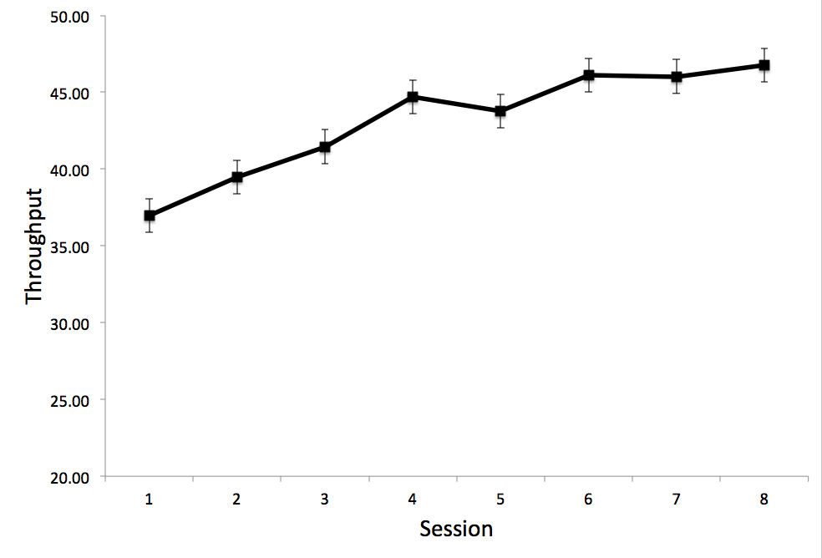 |  |  |  |  |  |  |  |  |  | 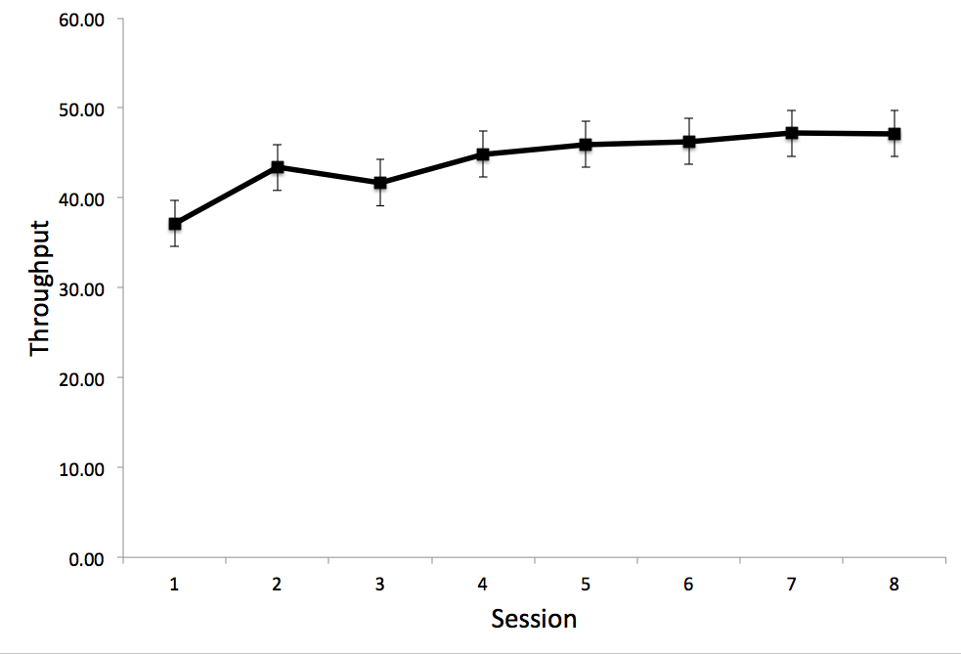
Stabilization
Throughput performance on GDCCT Matching plateaus at Session 6 |  |  |  |  |  |  |  |  |  | Throughput performance on GDCCT Memory plateaus at Session 4
Correlations with Similar Neurocognitive Tests
Matching |  |  |  |  |  |  |  |  |  | Memory
DANA Code Substitution Test (Matching)  - Moderately correlated for response time (r_{p} = .58) and throughput (r_{p} = .57)  - Weakly correlated for accuracy (r_{p} = .35)  WinSCAT Code Substitution Test (Learning)  - Strongly correlated for response time (r_{p} = .71)  - Moderately correlated for throughput (r_{p} = .57) and accuracy (r_{p} = .48)  WAIS-IV Symbol Search  - Weak correlation between Symbol Search score and GDCCT response time (r_{p} = -.37)  TOVA  - Weak correlation between GDCCT response time and TOVA response time (r_{p} = .20)  - Weak correlation between GDCCT response time and TOVA miss rate (r_{p} = .20)  - Weak correlation between GDCCT accuracy and TOVA false alarm rate (r_{p} = - .29) |  |  |  |  |  |  |  |  |  | DANA Code Substitution Test (Memory)  - Weakly correlated for response time (r_{p} = .37)  - Moderately correlated for throughput (r_{p} = .51) and accuracy (r_{p} = .53)  WinSCAT Code Substitution Test (Memory)  - Moderately correlated for response time (r_{p} = .57), throughput (r_{p} = .50), and accuracy(r_{p} = .44)  WAIS-IV Symbol Search  - Weak correlation between Symbol Search score and GDCCT response time (r_{p} = -.30)  TOVA  - Weak correlation between GDCCT response time and TOVA response time (r_{p} = .24)  - Weak correlation between GDCCT response time and TOVA false alarm rate (r_{p} = -.29)
Test-Retest Reliability Comparisons with Similar Neurocognitive Tests
 |  | 1-Week  Test-Retest  Reliability |  |  |  |  |  |  | 4-Week  Test-Retest  Reliability |  |  |  |  |  |  |  |  | Medical Scenario  Test-Retest Reliability
 |  | Matching |  | Memory |  |  |  |  | Matching |  |  |  | Memory |  |  |  |  | Matching |  |  |  | Memory
GDCCT |  | .835 |  | .612 |  |  |  |  | .867 |  |  |  | .436 |  |  |  |  | .815 |  |  |  | .606
DANA Code Substitution |  | .846 |  | .774 |  |  |  |  | .837 |  |  |  | .780 |  |  |  |  | .915 |  |  |  | .747
WinSCAT Code Substitution |  | .504 |  | .603 |  |  |  |  | .564 |  |  |  | .705 |  |  |  |  | .745 |  |  |  | .741
Table 5-8: GDCCT Validation Results

5.7.6 GDCCT Output File Variable Descriptions
Variable Name | Description
ID | Participant ID
Date_Time | Date/Time stamp: YYYY_MM_DD_HH:MM:SS
SessionMode | Session mode (0=Training, 1=Mission)
SessionID | Participant session number
Phase | Phase number (1=Matching; 2=Memory)
Trial | Trial number count (80 for Matching; 20 for Memory)
Trial_Type | Trial type (0=Non-Match, 1=Match)
Target_digit_code | Numeric code for digit in digit-symbol pair (1-10)
Target_symbol_code | Numeric code for symbol in digit-symbol pair (1-10)
Response | Participant’s response (0=Non-Match, 1=Match)
RT | Response time in seconds
ACC | Response accuracy (-1=No response, 0=Incorrect, 1=Correct)
Table 5-9: GDCCT Output File Variable Descriptions

5.8 Training Session 8

5.8.1 Session Name
Letter-Number Sequencing Auditory Task (LNSAT)
5.8.2 Task Description
The LNSAT is a mission task that you have to perform in an off-nominal situation. The Rover’s receiver intercepts a string of coded messages from the ISRU-site transmitter. Due to a mechanical failure, the ISRU antenna is not functional and communication with Earth is interrupted. While ground operators are working hard to solve the malfunction, you must listen to auditory messages, decode them one by one, and textually transmit the deciphered (reordered) messages to Mission Control. Each coded auditory message consists of an alternating sequence of numbers and letters. The length of the messages begins at two letters and two numbers and increases over time up to a maximum of eight letters and eight numbers. Messages are read at a rate of one number/letter per second.
5.8.3 Task Instructions
To decode the coded messages for the Mission Control Center, you will have to carefully listen to the letters and numbers, which are presented at a rate of one per second. After the last letter or number is presented, the input field will be enabled. Type the numbers and letters you heard in the input field, but reorder them as follows: Mentally group the numbers and letters separately. Then mentally sort the numbers in ascending order and the letters in alphabetical order (see examples in Table 5-2). You can enter the (grouped and ordered) numbers or letters first. When finished, press the <Enter> key (Figure 5-8).

Level | Message # | Sequence Heard  (Coded Message) | Response  (Decoded Message)
2 | 1 | 5 F 2 C | 2 5 C F
2 | 2 | 9 S 6 G | 6 9 G S
3 | 1 | 6 A 2 X 8 U | 2 6 8 A U X
3 | 2 | 9 S 7 G 1 K | 1 7 9 G K S
…
Table 5-10: Examples of Coded and Decoded Messages

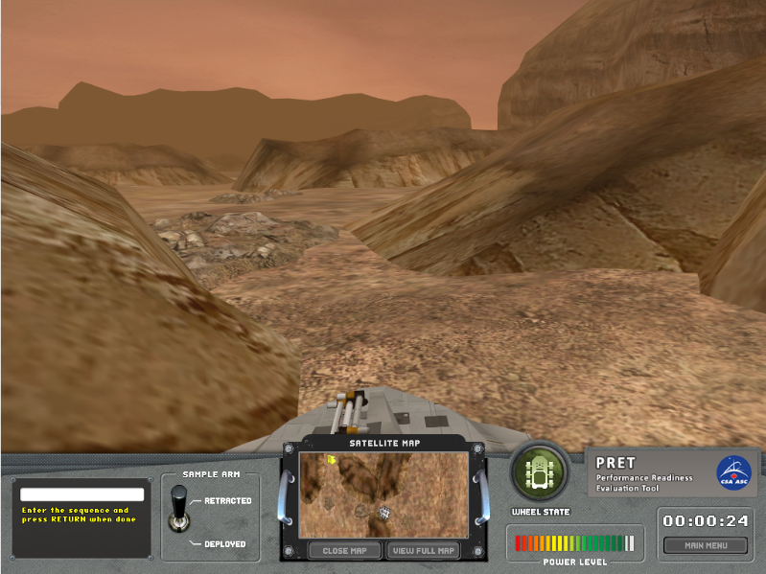
Figure 5-8: LNSAT
5.8.4 Task Lessons
Improve your memory and skills in analyzing and reordering auditory information in an off- nominal situation.

5.8.5 LNSAT Validation Results Table
Letter-Number Sequencing Auditory Task (LNSAT)
What Does the LNSAT Measure? The LNSAT measures the ability to store and then mentally group and reorder information from two classes (letters and number) of aurally presented stimuli.

Test Duration | Mean (s) |  | Median (s) |  |  | Std. Dev. (s) |  |  | Minimum (s) |  |  |  |  |  | Maximum (s)
 | 69 |  | 69 |  |  | 29 |  |  | 33 |  |  |  |  |  | 133
Distributional Characteristics |  |  |  | Response Time |  |  | Throughput |  |  | Max Trial Level |  |  |  | Accuracy
Mean |  |  |  | 7174 ms |  |  | 5.0 |  |  | 3.5 |  |  |  | 48.6 %
Median |  |  |  | 7019 ms |  |  | 4.9 |  |  | 3.0 |  |  |  | 49.6 %
Std. Dev. |  |  |  | 1770 ms |  |  | 1.6 |  |  | .68 |  |  |  | 7.4 %
Inter-Quartile Range |  |  |  | 2652 ms |  |  | 1.3 |  |  | 1.0 |  |  |  | 8.2 %
Minimum |  |  |  | 3709 ms |  |  | 1.8 |  |  | 2.0 |  |  |  | 20.0 %
Maximum |  |  |  | 10995 ms |  |  | 10.4 |  |  | 5.0 |  |  |  | 58.6 %
Skewness |  |  |  | .253 |  |  | 1.11 |  |  | .711 |  |  |  | -1.55
Kurtosis |  |  |  | -.440 |  |  | 2.40 |  |  | .144 |  |  |  | 4.56
Normally Distributed? |  |  |  | Yes |  |  | No |  |  | No |  |  |  | No
Spearman Test-Retest Reliability |  |  |  | 1-Week |  |  |  | 4-Week |  |  |  |  | Medical Scenario
 |  |  |  | .178 |  |  |  | .387 |  |  |  |  | .525
Learning Curve |  |  |  |  |  |  |  |  |  |  | Stabilization
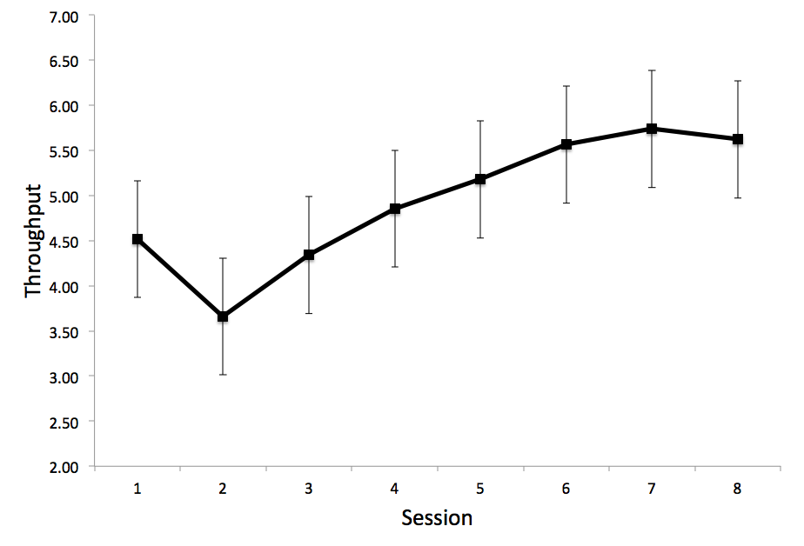 |  |  |  |  |  |  |  |  |  |  | Throughput performance on the LNSAT plateaus at Session 4
Correlations with Similar Neurocognitive Tests
DANA Match To Sample Test
- Weakly correlated for response time (r_{p} = .25) and accuracy (r_{p} = .25)

WinSCAT Match To Sample Test
- Weakly correlated for accuracy (r_{p} = .37)

WAIS-IV Arithmetic
- Weak correlation between LNSAT accuracy and WAIS Arithmetic score (r_{p} = .28)
- Moderate correlation between LNAT maximum trial level and WAIS Arithmetic score (r_{p} = .42)

WAIS-IV Letter-Number Sequencing
- Weak correlation between LNSAT accuracy and WAIS Letter-Number Sequencing score and LNSAT accuracy (r_{p} = .21)
- Weak correlation between LNSAT maximum trial level and WAIS Letter-Number Sequencing score (r_{p} = .33)
Test-Retest Reliability Comparisons with Similar Neurocognitive Tests
 |  | 1-Week  Test-Retest  Reliability |  |  | 4-Week  Test-Retest  Reliability |  |  |  |  |  |  | Medical Scenario  Test-Retest Reliability
LNSAT |  | .178 |  |  | .387 |  |  |  |  |  |  | .525
DANA  Match to Sample |  | .633 |  |  | .435 |  |  |  |  |  |  | .635
WinSCAT  Match to Sample |  | .693 |  |  | .796 |  |  |  |  |  |  | .646
Table 5-11: LNSAT Validation Results

5.8.6 LNSAT Output File Variable Descriptions
Variable Name | Description
ID | Participant ID
Date_Time | Date/Time stamp: YYYY_MM_DD_HH:MM:SS
SessionMode | Session mode (0=Training, 1=Mission)
SessionID | Participant session number
Trial | Trial number
TrialLevel | Number of digits/letters in current sequence
Attempt | Attempt at current trial level (1=1st attempt, 2=2nd attempt)
Sequence | Letter-number sequence on current trial
Response | Participant’s response
RT | Response time in seconds
ACC | Response accuracy (-1=No response, 0=Incorrect, 1=Correct)
Table 5-12: LNSAT Output File Variable Descriptions

5.9 Training Session 9

5.9.1 Session Name
Suspension Check Task (SCT)
5.9.2 Task Description
The SCT is a routine mission task that you have to perform to verify that the Rover’s wheels are in proper working condition. The SCT is an electronic and mechanical check to determine whether the six independent wheel suspensions are fully functional. Each time a wheel is checked, a flag on the wheel state indicator panel will turn green. This diagnostic procedure is composed of several sub-component tests. To avoid repeating an identical sub-component test (constantly activated due to a repetitive safety process), you have to press a response key as quickly as possible when a flag appears on the wheel state indicator panel. The suspension check procedure will end after all the sub-tests have been completed.
5.9.3 Task Instructions
To perform the Rover wheel suspension check, you have to attend to the wheel state indicator, which has been magnified and centred on the screen (see Figure 5-9). Press the spacebar as quickly as you can when a green flag on the Rover’s wheel state indicator appears. Your response time is displayed immediately after pressing the response key (Figure 5-10).

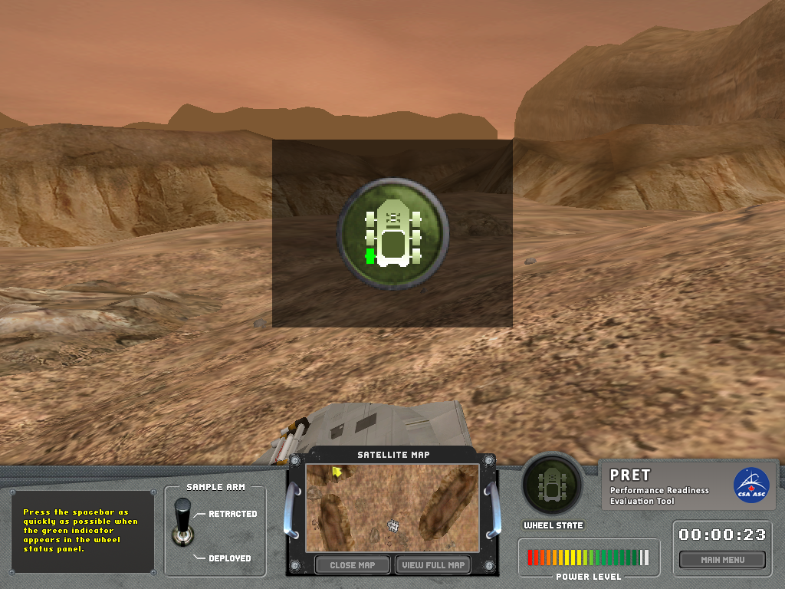
Figure 5-9: SCT

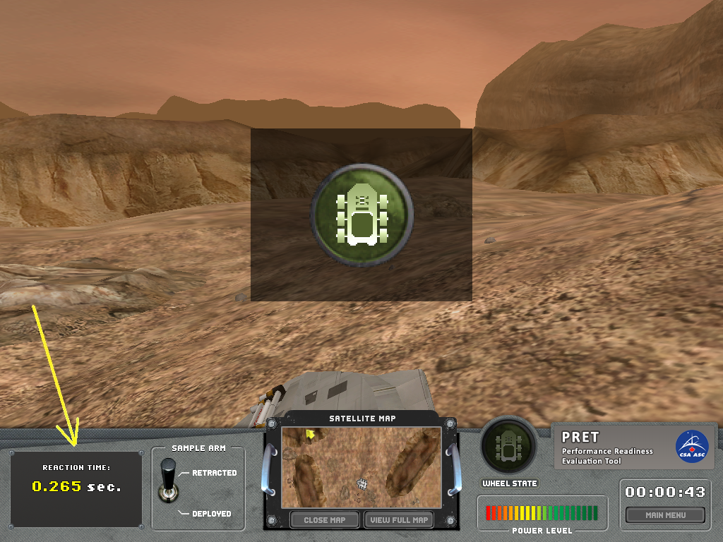
Figure 5-10: Response Time Display
5.9.4 Task Lessons
Improve your response time in high stress situations.

5.9.5 SCT Validation Results Table
Suspension Check Task (SCT)
What Does the SCT Measure? The SCT measures simple response times to visual stimuli.

Test Duration | Mean (s) |  | Median (s) |  |  | Std. Dev. (s) |  |  |  | Minimum (s) |  |  |  |  | Maximum (s)
 | 104 |  | 104 |  |  | 3 |  |  |  | 95 |  |  |  |  | 112
Distributional Characteristics |  |  |  | Response Time |  |  |  | Throughput |  |  | Hit Rate |  |  |  |  | False Alarm Rate
Mean |  |  |  | 351 ms |  |  |  | 153.5 |  |  | 87.8 % |  |  |  |  | 1.0 %
Median |  |  |  | 348 ms |  |  |  | 155.7 |  |  | 90.0 % |  |  |  |  | 0.0 %
Std. Dev. |  |  |  | 33 ms |  |  |  | 31.3 |  |  | 10.9 % |  |  |  |  | 2.8 %
Inter-Quartile Range |  |  |  | 50 ms |  |  |  | 42.9 |  |  | 13.3 % |  |  |  |  | 0.0 %
Minimum |  |  |  | 291 ms |  |  |  | 61.2 |  |  | 45.0 % |  |  |  |  | 0.0 %
Maximum |  |  |  | 439 ms |  |  |  | 204 |  |  | 100.0 % |  |  |  |  | 20.0 %
Skewness |  |  |  | .324 |  |  |  | -.483 |  |  | -1.36 |  |  |  |  | 4.30
Kurtosis |  |  |  | -.551 |  |  |  | -.090 |  |  | 2.17 |  |  |  |  | 22.7
Normally Distributed? |  |  |  | No |  |  |  | No |  |  | No |  |  |  |  | No
Spearman Test-Retest Reliability |  |  |  |  | 1-Week |  |  |  | 4-Week |  |  |  |  | Medical Scenario
 |  |  |  |  | .603 |  |  |  | .816 |  |  |  |  | .819
Learning Curve |  |  |  |  |  |  |  |  |  |  |  | Stabilization
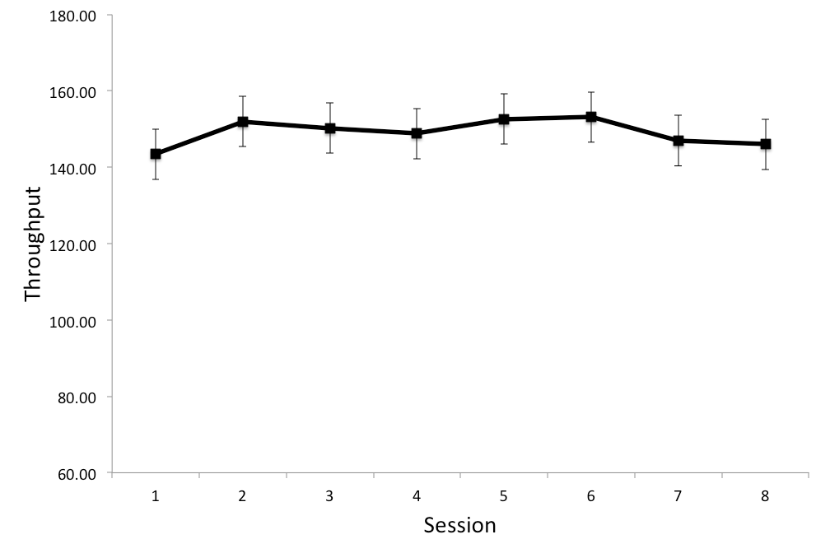 |  |  |  |  |  |  |  |  |  |  |  | There was no change in throughput performance on the SCT across sessions
Correlations with Similar Neurocognitive Tests
DANA Simple RT Test
- Strongly correlated for response time (r_{p} = .60)
- Moderately correlated for throughput (r_{p} = .52)
- Weakly correlated for hit rate (r_{p} = .33)

Psychomotor Vigilance Test (PVT)
- Strong correlation between PVT response time and SCT response time (r_{p} = .63)
- Moderate correlation between PVT response time and SCT hit rate (r_{p} = -.47)
- Weak correlation between SCT response time and PVT hit rate (r_{p} = -.27)
- Weak correlation between SCT hit rate and PVT hit rate (r_{p} = .33)

TOVA
- Moderately correlated for response time (r_{p} = .47)
- Weak correlation between SCT hit rate and TOVA response time (r_{p} = -.34)
- Weak correlation between SCT response time and TOVA false alarm rate (r_{p} = -.27)
- Weak correlation between SCT hit rate and TOVA misses (r_{p} = -.26)
Test-Retest Reliability Comparisons with Similar Neurocognitive Tests
 |  | 1-Week  Test-Retest  Reliability |  |  |  |  | 4-Week  Test-Retest  Reliability |  |  |  |  |  | Medical Scenario  Test-Retest Reliability
SCT |  | .603 |  |  |  |  | .816 |  |  |  |  |  | .819
DANA  Simple RT |  | .478 |  |  |  |  | .792 |  |  |  |  |  | .826
Table 5-13: SCT Validation Results

5.9.6 SCT Output File Variable Descriptions
Variable Name | Description
ID | Participant ID
Date_Time | Date/Time stamp: YYYY_MM_DD_HH:MM:SS
SessionMode | Session mode (0=Training, 1=Mission)
SessionID | Participant session number
Trial | Trial number (1-20)
RT | Response time in seconds
ACC | Response accuracy (-1=Cheat [RT<200ms], 1=Hit)
Table 5-14: SCT Output File Variable Descriptions

6 Installation Instructions

6.1 Installing CSA PRET Simulator
PRET is supported on machines running Windows XP or newer versions of Windows. To install the CSA PRET Simulator:
- Open the compressed zip file containing PRET
- Drag the folder named “CSA” to C:\
- Drag the “PRET-R Shortcut” file to the desktop

6.2 Video Settings
If you run the simulator on a low to medium performance computer, modify the video options, which are accessible from the “Options” menu button located in the main menu widow (see Figure 4-3), by choosing minimal video settings. Then click the “save” button (Figure 6-1). Note that the “Auto Login” checkbox in the session manager (Figure 4-2) cannot be checked in order to access the video settings.

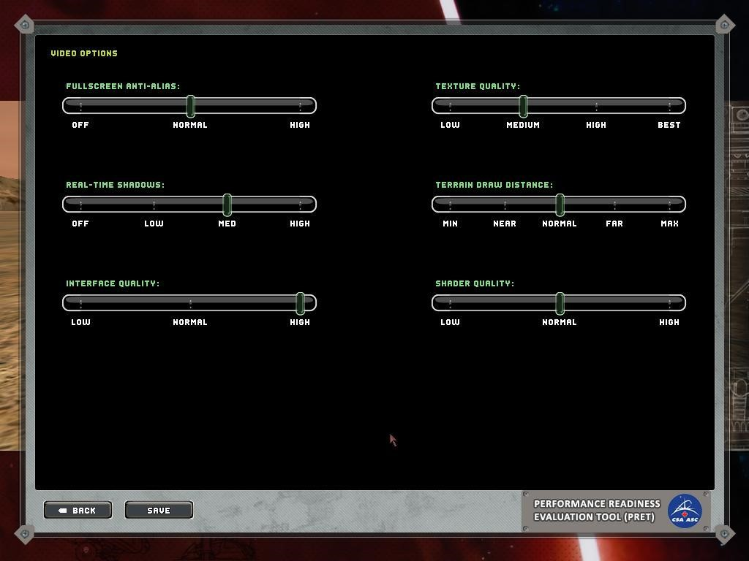
Figure 6-1: Video Settings Window

