canadian space AGENCY

Space Science and technology

LIBS for Planetary analogue missions

LIBS data set for geological materials for planetary exploration

REV. A

January 19, 2017

THIS PAGE IS INTENTIONALLY LEFT BLANK

Preface

This document, titled LIBS FOR PLANETARY ANALOGUE MISSIONS, LIBS data set for geological materials for planetary exploration, must be approved by the undersigned.
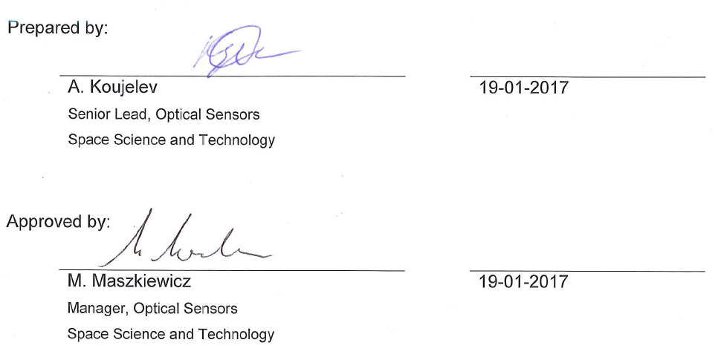
Prepared by:

A. Koujelev  Senior Lead, Optical Sensors  Space Science and Technology |  | 19-01-2017

Approved by:

M. Maszkiewicz  Manager, Optical Sensors  Space Science and Technology |  | 19-01-2017

Revision History

Revision | Description | Issue Date | Initials
1 | Initial Release | 09-09-2016 | AK
2 | Rev A | 19-01-2017 | AK

Table of Contents
Preface iii
Revision History iv
Table of Contents v
List of Tables vi
1 General Information 1
1.1 Introduction 1
1.2 Reference publications 1
2 LIBS Data Acquisition 2
2.1 Experimental setup 2
2.2 Samples 2
2.3 Spectra acquisition 2

List of Tables

Table 1 – A summary of the experimental conditions. 2

General Information

Introduction
This document describes the context and conditions of data set acquisition for the purpose of algorithm development for Laser-Induced Breakdown Spectroscopy (LIBS). The project under which the data were acquired targets application of LIBS to Planetary Analogue Missions, conducted by Space Science & Technology and its collaborators for the Exploration Core Program in 2010 - 2013.

Additional information about the context of the project and the data collected can be found in publications resulted from this study [1-7].

Reference publications
[1] C. Lefebvre, A.Catalá-Espí, P.Sobron, A.Koujelev, R.Léveillé, (2016) “Depth-resolved chemical mapping of rock coatings using Laser-Induced Breakdown Spectroscopy: Implications for geochemical investigations on Mars,“ Planetary and Space Science, Vol.126, pp.24–33.
[2] P. Sobron, C. Lefebvre, R. Leveille, A. Koujelev, T. Haltigin, H. Du, A. Wang, N. Cabrol, K. Zacny, J. Craft, and the LiTA 2012 Team (2013) “Geochemical profile of a layered outcrop in the Atacama analogue using laser-induced breakdown spectroscopy (LIBS) - Implications for Curiosity investigations in Gale,” Geophysical Research Letters, Vol. 40, pp. 1–6.
[3] S.L. Lui & A. Koujelev, (2011) “Accurate identification of geological samples using artificial neural network processing of laser-induced breakdown spectroscopy data,” Journal of Analytical Atomic Spectroscopy, Vol. 26, pp. 2419 – 2427.
[4] A. Koujelev & S.L. Lui, (2011) “Artificial neural networks for material identification, mineralogy and analytical geochemistry based on laser-induced breakdown spectroscopy,” in a book Artificial Neural Networks - Industrial and Control Engineering Applications, Book edited by: Kenji Suzuki, Publisher: InTech, Chapter 4, pp. 91-116.
[5] A. Koujelev, M. Sabsabi, V. Motto-Ros, S. Laville, and S.L. Lui, (2010) “Laser-induced breakdown spectroscopy with artificial neural network processing for material identification,” Planetary and Space Science, Vol. 58, pp. 682-690.
[6] A. Koujelev, V. Motto-Ros, D. Gratton and A. Dudelzak, (2009) “Laser-induced breakdown spectroscopy as geological tool for field planetary analogue research,” Canadian Aeronautics and Space Journal, Vol. 55, pp. 97–106.
[7] V. Motto-Ros, A. S. Koujelev, G. R. Osinski, and A. E. Dudelzak, (2008) “Quantitative multi-elemental laser induced breakdown spectroscopy using artificial neural network,” Journal of the European Optical Society - Rapid Publications, Vol. 3, 08011.

LIBS Data Acquisition

Experimental setup
A typical laboratory LIBS setup was used. A laser beam of 20 mJ pulse energy (Nd:YAG laser, Spectra Physics, LPY150) is focused by a 7.5 cm lens onto the target to create optical breakdown. The emission from the breakdown plasma is collimated with same lens and collected to a spectrometer (Ocean Optics LIBS 2000). The spectral range covered is from 200 nm to 970 nm with a resolution of 0.1 nm. Thus each data file contains two columns: wavelength and counts for total 13490 rows. In the Table 1, the key experimental conditions are listed.

Table 1 – A summary of the experimental conditions.
Parameter |  | Value
Laser pulse energy, mJ |  | 20
Laser beam wavelength, nm |  | 1064
Laser pulse duration, ns |  | 7
Laser repetition rate, Hz |  | 2
Laser beam diameter at the output, mm |  | 2.1
Laser beam diameter on the sample, mm |  | 0.1-0.4
Sensing distance, cm |  | 7.5
Spectral range, nm |  | 200-970
Pressure, atm |  | 1
Temperature, deg C |  | 23
Atmosphere |  | Ambient

Samples
The 39 certified geological powders are purchased from Brammer Standard Company. They are pressed into tablets for easy handling. Additional test samples come from 29 rocks supplied by Miners Inc., referred as hand samples. These samples are externally tested for their elemental composition by Actlabs Ltd.

A separate data file (Sample_Composition_Data.xls) presents the elemental composition for all certified and hand samples.

Spectra acquisition
For the certified samples, we recorded a total of 1000 spectra from 10 different spots on each sample of the certified set. The average spectrum for each sample is presented in the data set (folder “Certified Samples Subset 1000pulseaverage”).

Another set of average of 200 spectra is also recorded for the certified sample set and for the hand samples. A total of 200 spectra from 2 different spots were obtained on each sample. Again, the average spectrum is presented in the data set (folder “Material Large Set 200pulseaverage”).

